**Table of Contents**

**1. Executive Summary………………………………………………………………………..2**

1.1. Project Overview……………………………………………………………………………...2

1.2. Purpose and Scope of this Specification…………………………………………………...2

**2. Product/Service Description……………………………………………………………...4**

2.1. Product Context………………………………………………………………………………4

2.2. User Characteristics………………………………………………………………………….4

2.3. Assumptions…………………………………………………………………………………..5

2.4. Constraints……………………………………………………………………………………5

2.5. Dependencies………………………………………………………………………………...5

**3. Requirements……………………………………………………………………………….5**

3.1. Functional Requirements……………………………………………………………………11

3.2. Non-Functional Requirements……………………………………………………………...17

3.2.1. Product Requirements………………………………………………………………...18

3.2.1.1. User Interface Requirements………………………………………………..18

3.2.1.2. Usability………………………………………………………………………..18

3.2.1.3. Efficiency………………………………………………………………………19

3.2.1.3.1 Performance Requirements……………………………………...19

3.2.1.3.2 Space Requirement……………………………………………….19

3.2.1.4. Dependability…………………………………………………………………..21

3.2.1.5. Security………………………………………………………………………...22 . 3.2.2. Organizational Requirements………………………………………………………....22

3.2.2.1. Environmental Requirements………………………………………………..23

3.2.2.2. Operational Requirements…………………………………………………...23

3.2.2.3. Development Requirements…………………………………………………23

3.2.3. External Requirements…………………………………………………………………23

3.2.3.1. Regulatory Requirements……………………………………………………23

3.2.3.2. Ethical Requirements………………………………………………………...24

3.2.3.3. Legislative Requirements……………………………………………………24

3.2.3.3.1. Accounting Requirements……………………………………….24

3.2.3.3.2. Security Requirements…………………………………………..24

3.3. Domain Requirement………………………………………………………………………...24

**4. Software Design…………..……………………………………………………………….25**

4.1. User Scenarios……………………………………………………………………………….25

4.2. Use Case……………………………………………………………………………………...41

4.3. Use Case Extended………………………………………………………………………….48

4.4. Data flow diagram……………………………………………………………………………63

4.5. Activity diagram……………………………………………………………………………...65

4.6. Collaboration diagram………………………………………………………………………79

4.7. Sequence diagram………………………………………………………………………….83

4.8. Class diagram……………………………………………………………………………….86

4.9. ER diagram………………………………………………………………………………….87

4.10. Object diagram……………………………………………………………………………...88

4.11. Component diagram………………………………………………………………………..89

4.12. Deployment diagram……………………………………………………………………...90

# 1. Executive Summary

## 1.1 Project Overview

Our project’s aim is to create a software application to solve the technical issues for a kindergarten in Tirana. The software’s name is ABC, same as the kindergarten, and its main idea is to provide technological help to the kindergarten administrator, employees and parents of children, to fix all the communications bugs that exist within the business. In the front end the administrator, the teacher, the employee, the psychologist and parents who will have permission will see the page created with JavaScript /Bootstrap or JSON and will access to each of the child’s date like his name, age, parent contact and any detail related with the monthly payment or his advance through the time he has been there. On the back end we will work with PHP technology and all the data will be saved in a specific database. This will provide help to the kindergarten owner, administrator, economist, employee or people from human resources that work there and also the parents of the children. Based on the economic research we will do for the kindergarten, every problem the audience can’t get through is our project aim to solve.

A visual representation would be:

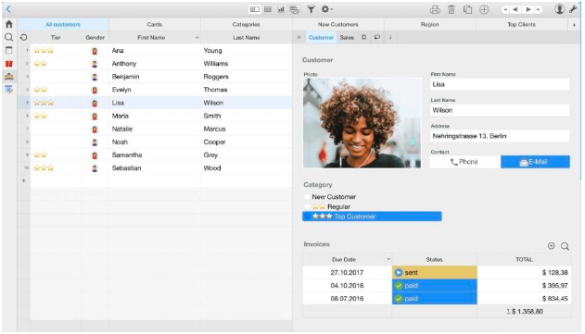

## 1.2 Purpose and Scope of this Specification

In scope

● Its aim is to conduct data from the specified database.

● For the administrator, he will be able to use the data provided to check with the advancement of the children or economic issues (like monthly payments).

● It will be user-friendly and with some simple buttons, you can be able to take the information needed.

● You can add information all the time or remove data.

● Employees can access the web page via their respective accounts and log in their data or extract data from the application.

● Parents can access their accounts very easily and get data about their children information, the activities the kindergarten is doing or pay their monthly fee.

● Legislative issues like the conduct of research is lawful and it data will not be misused.

**Out of Scope**

● Our aim is to help the kindergarten administrator or human resource staff or economist and it’s not our aim to provide information to outsiders

● Parents (customers) are an important part of the research and the use of application, the app is user friendly to help them get data for their children.

● This is not a demand from the customer side, but will help them a lot in time. They could access the page anytime without calling the staff of the kindergarten or going there themselves.

● Relations between the kindergarten and the kindergarten administrator will be affected.

● Relations between the kindergarten employees (teachers) and parents will be improved.

● Relation between employees and administrator of the kindergarten will be easy. Data accessible all the time.

# 2. Product/Service Description

## 2.1 Product Context

This product is independent and self-contained; it has no relation to other businesses except the ABC kindergarten even though we conducted a market analysis to analyze the other technologies competitors were using. Within the kindergarten itself it is related with the processes around the business itself, every data related to the customer (in our case the children and their parents) is the base for the functioning of our software. So the software is dependent on the database that will provide the information for each child for their education field and also about the economic problems. If the kindergarten won’t provide data then the software

would be useless because by collecting data through time it will help to find them easier again in the future and reuse.

Features of the Software of the Kindergarten

User-friendly

Data from Parent in ABC Software

(address, job, monthly payments)

software included on ours, like Gmail.

Children Data (their consistency on learning)

2.2 User Characteristics

Our software will include five users, the administrator of the kindergarten who accesses the database of the children, economist: responsible for the economic activity and description of the balance sheets and VAT calculation, parents who can access only information for their own children and can communicate with the teacher responsible, the psychologist: responsible for the mental health of the children and responsible for communicating with parents and writing reports to administrators. All users will access their information and their respective pages only by logging in their web account.

Technical expertise for the software of course is granted by us since the kindergarten doesn’t have an IT specialist. Security will also be checked from the supervisors of the administrator, who can be the owner itself or human resource specialists.

## 2.3 Assumptions

The system administrator should always keep the system up to date every day. All information of the day of each child should be sent to the respective day, every day. Every operation and action taken during that day, should be written on the

System, not days later. Ex: if a payment is done, today it should be registered today, if the system does not work then it should be written in a diary or the economist must send a note or email to the administrator and on the day that it should be registered, the economist will leave a comment about the exact day of payment. The teachers every day can change information about the kids, if they have any specific needs, did something extra during the day, eat, slept, and took part in activities or their attendance. Also the parents will be able to track their children's progress on the other side and also complete bills to the kindergarten, pay their monthly fee or other payments needed in specific cases or activities.

2.4 Constraints

Before we used to keep our data in Excel and Word files and before we start working with the software we should spend some time transferring data from those files to the app. The kindergarten will not have an IT specialist working all time there, so sometimes that the administrator may have problems, they will have to wait for our service and this may take a bit longer. Also, for the security reasons because that software will have much confidential and personal information we should have a file for log-ins in the app. This app is going to work only on computers and may be difficult if the administrator would like to use it on the phone or somewhere else.

2.5 Dependencies

Our software program will be extremely dependent on the Database that will provide the information for each child for their education field and also about the economic problems. If the kindergarten won’t provide data then the software would be unuseful. We are also dependent on the parents a little bit, if they do not like the idea of only sending them Whatsapp messages, we have to change the way of keeping them up to date, anyways this can happen after we start using the app in the kindergarten.

# 3. Requirements

## 3.1 Functional Requirements

|  |  |  |  |  |  |
| --- | --- | --- | --- | --- | --- |
| REQ# | Requirements | Comments | **Priority** | Date | Reviewed  Approved |
| BR_01 | The system is designed as a desktop application with two users. | This will be the main platform for users | 2 | 21/04/2020 | Amela  Rahimi & Sindi Kalo |
| BR_02 | The administrator of the system will have all the privileges. Will access in real time all the options of the system and the database for children and employees. | Admin account has access in all functionalities of the system | 1 | 21/04/2020 | Amela  Rahimi & Sindi Kalo |
| BR_03 | Graphical data will be provided for the administrator and should be accessible all the time. | This is really important because for the administrator because he must have a clear view of the graphical data in order to access quicker the database | 2 | 21/04/2020 | Amela  Rahimi & Sindi Kalo |
| BR_04 | The system must provide the option for the administrator to register new children and new employees in the kindergarten. | This is very useful because it makes it easier to coordinate the teacher work since children are in groups and it gives facilities to the admin in order to see how much employees has and all their information. | 2 | 21/04/2020 | Amela  Rahimi & Sindi Kalo |
| BR_05 | Children and employees can be registered only by admin using the email of the kindergarten. | It is useful to identify the real children and employees of the kindergarten. | 1 | 21/04/2020 | Amela  Rahimi & Sindi Kalo |
| BR_06 | The administrator can log in by username and password | To provide easier log in for admin without using an email | 1 | 21/04/2020 | Amela  Rahimi & Sindi Kalo |

|  |  |  |  |  |  |
| --- | --- | --- | --- | --- | --- |
| BR_07 | The administrator can register new children by providing also other information such as: name, surname, parents name, address, email, date of birth. | The database created with these information will be one of the main operations of the admin | 2 | 21/04/2020 | Amela  Rahimi & Sindi Kalo |
| BR_08 | The administrator can register new employees by providing also other information such as: name, surname, address, email, date of birth and of course the paycheck. | The database created with these information will be one of the main operations of the admin | 2 | 21/04/2020 | Amela  Rahimi & Sindi Kalo |
| BR_09 | The administrator can see the data in a tabular form.This is done because tables and graphics give a more clear overview of all the children registered. There will be options for the administrator that make him able to delete or edit unnecessary information | Through these options the system will never be out of date because the admin will refresh it with new information but also deleting old information about children | 2 | 21/04/2020 | Amela  Rahimi & Sindi Kalo |
| BR_10 | The administrator can see the data in a tabular form.This is done because tables and graphics give a more clear overview of all the employees registered. There will be options for The administrator that make him able to delete or edit unnecessary information | Through these options the system will never be out of date because the admin will refresh it with new information but also delete old information about employees. | 2 | 21/04/2020 | Amela  Rahimi & Sindi Kalo |
| BR_11 | The admin can add children by creating an account for them with their name, surname, parents name, date of birth and email in their parents name in the form:[namesurname@edcationabc.al](mailto:namesurname@edcationabc.al) | This way the admin will have all the information and it would be easier to access. | 2 | 21/04/2020 | Amela  Rahimi & Sindi Kalo |
| BR_12 | The admin can add employees by creating an account for them with their name, surname, date of birth and email in the form:[namesurname@edcationabc.al](mailto:namesurname@edcationabc.al) and there will be a booton with a tick watermark if the employee has taken the salary. | This way the admin will have all the information and it would be easier to access and to not create delays with the paycheck of different employees. | 2 | 21/04/2020 | Amela  Rahimi & Sindi Kalo |

|  |  |  |  |  |  |
| --- | --- | --- | --- | --- | --- |
| BR_13 | The admin will have the opportunity to edit and delete other sections of the system as: activities and general information for the kindergarten that will be viewed by parents also | These two sections are made to promote the business to the parents and to keep them updated to the latest news of the activities. | 2 | 21/04/2020 | Amela  Rahimi & Sindi Kalo |
| BR_14 | The admin can add also new events in the activities section which will be visible for all the parents | The admin will have access to both these two sections. | 2 | 21/04/2020 | Amela  Rahimi & Sindi Kalo |
| BR_15 | The admin will be able to create a quick note for every employee | This will serve to a deeper understanding of the admin and employees an of course to improve their work | 2 | 21/04/2020 | Amela  Rahimi & Sindi Kalo |
| BR_16 | The admin will be able to have In every page of each child the phone number of one of their parents and when clicked will link immediately to WhatsApp. | WhatsApp is the common and the most useful communication tool that the admin has used with the parents until now | 1 | 21/04/2020 | Amela  Rahimi & Sindi Kalo |
| BR_17 | the admin will be able to have In every page of each child there the email address in the above mentioned format of their parents and when clicked will link immediately to gmail. | This is a second and a more official communication tool. | 1 | 21/04/2020 | Amela  Rahimi & Sindi Kalo |
| BR_18 | the admin will be able to have In every page of every employee the phone and when clicked will link immediately to WhatsApp. | WhatsApp is the common and the most useful communication tool that the admin has used with the employees until now | 1 | 21/04/2020 | Amela  Rahimi & Sindi Kalo |
| BR_19 | the admin will be able to have In every page of each employee the email address in the above mentioned format of their parents and when clicked will link immediately to gmail. | This is a second and a more official communication tool example: paychecks | 1 | 21/04/2020 | Amela  Rahimi & Sindi Kalo |

|  |  |  |  |  |  |
| --- | --- | --- | --- | --- | --- |
| BR_20 | The admin will have a print option | The print option will serve as a document in case one of the parent wants a summary of all the time that his child has been in the kindergarten | 2 | 21/04/2020 | Amela  Rahimi & Sindi Kalo |
| BR_21 | The admin will be able to see if the parents have or have not done the payment | Here the admin will check the tick sign in each children account and will transmit to the economist. | 1 | 21/04/2020 | Amela  Rahimi & Sindi Kalo |

|  |  |  |  |  |  |
| --- | --- | --- | --- | --- | --- |
| BR_22 | The admin will be able to see the weekly reports for each teacher. | In this way the admin can evaluate the job and tasks assigned to each teacher and also be aware of the problems that every group has. | 2 | 21/04/2020 | Amela  Rahimi & Sindi Kalo |

|  |  |  |  |  |  |
| --- | --- | --- | --- | --- | --- |
| BR_23 | The admin can write feedback for each report. | The report will help teachers to improve. | 2 | 21/04/2020 | Amela  Rahimi & Sindi Kalo |

|  |  |  |  |  |  |
| --- | --- | --- | --- | --- | --- |
| BR_24 | The admin can change the password and the username in the setting section. | He is responsible for his own settings. | 1 | 21/04/2020 | Amela  Rahimi & Sindi Kalo |
| BR_25 | The parents is the second user | The accessibility of the parent is limited. | 1 | 21/04/2020 | Amela  Rahimi & Sindi Kalo |
| BR_26 | Parents will log in only by the email that it was first created and the password | This is done for security reasons so that only the real parent can have access to the page of his child. | 1 | 21/04/2020 | Amela  Rahimi & Sindi Kalo |
| BR_27 | The parents will be able to write notes about the teacher of the their child | This will create a better communication with the teacher. | 1 | 21/04/2020 | Amela  Rahimi & Sindi Kalo |
| BR_28 | The parents will not be able to change the format of the email | This will be to avoid confusion and or a better and more clear view | 1 | 21/04/2020 | Amela  Rahimi & Sindi Kalo |
| BR_29 | Tha parents will be able to change the password | They will be responsible for their own settings | 2 | 21/04/2020 | Amela  Rahimi & Sindi Kalo |
| BR_30 | The parents will be able to view the information of ONLY their child | With email and password they will see the data of their own child | 1 | 21/04/2020 | Amela  Rahimi & Sindi Kalo |

|  |  |  |  |  |  |
| --- | --- | --- | --- | --- | --- |
| BR_31 | The parents will be able to edit the data of their own child and these changes will be reflected to the admin | This is done to create facilities in case some information of the page changes through the time. Example: the phone number | 2 | 21/04/2020 | Amela  Rahimi & Sindi Kalo |
| BR_32 | The parents will be able to leave a note at the end of the page of their child.This change will be reflected also to the admin | Parents may leave a note for the teacher or the admin in order to improve the services provided by the kindergarten | 2 | 21/04/2020 | Amela  Rahimi & Sindi Kalo |
| BR_33 | The parents will be able to receive messages on WhatsApp by the admin. | According to a survey that was made in kindergarten WhatsApp has resulted the most common communication tool. | 1 | 21/04/2020 | Amela  Rahimi & Sindi Kalo |
| BR_34 | The parents will be able to receive emails by the admin. | This will be for more official updates. | 2 | 21/04/2020 | Amela  Rahimi & Sindi Kalo |
| BR_35 | The parents will be able to view the activities tab. | In this tab they will be informed about the latest activity of the kindergarten, will have the possibility to view pictures. | 2 | 21/04/2020 | Amela  Rahimi & Sindi Kalo |
| BR_36 | The parents will be able to view the information tab. | Information tab is a tab that serves as promotion page and keeps information that admin wants to make public | 2 | 21/04/2020 | Amela  Rahimi & Sindi Kalo |

|  |  |  |  |  |  |
| --- | --- | --- | --- | --- | --- |
| BR_37 | The parents will not be able to edit or delete the activities tab or information tab | These two pages will be only for the admin since parents can give wrong information. | 1 | 21/04/2020 | Amela  Rahimi & Sindi Kalo |
| BR_38 | The parents will be able to see the name of the teacher of their child. | This will facilitate the communication between teacher and parent | 2 | 21/04/2020 | Amela  Rahimi & Sindi Kalo |
| BR_39 | The parents will be able to put a tick sign if they have done the monthly payment. This change will be reflected to the database of the admin | This will facilitate the admin job which will communicate to the economist | 1 | 21/04/2020 | Amela  Rahimi & Sindi KAmela |

|  |  |  |  |  |  |
| --- | --- | --- | --- | --- | --- |
| BR_40 | The parents will have the print option. | The print option will be available in the page of every child and parent will be able to print only the information of their child | 2 | 21/04/2020 | Amela  Rahimi & Sindi Kalo |

|  |  |  |  |  |  |
| --- | --- | --- | --- | --- | --- |
| BR_41 | The parents will be able to see the notes from the teacher. | This will facilitate their communication for special requests. |  | 21/04/2020 | Amela Rahimi & Sindi Kalo |

|  |  |  |  |  |  |
| --- | --- | --- | --- | --- | --- |
| BR_42 | The parents will be able to see the attendance. | They will see if their child is present or not but will not be able to edit it. | 2 | 21/04/2020 | Amela Rahimi & Sindi Kalo |
| BR_43 | The teachers will be the third user in our application system | The teacher's accessibility will be limited. | 1 | 21/04/2020 | Amela Rahimi & Sindi Kalo |
| BR_44 | The teachers will be able to log in by username and password | This is done for security reasons to provide the right information for each teacher | 2 | 21/04/2020 | Amela Rahimi & Sindi Kalo |
| BR_45 | The teachers will be able to see the profile picture. | This will serve as a confirmation that they are in their profile, but they will not be able to change it. | 2 | 21/04/2020 | Amela Rahimi & Sindi Kalo |
| BR_46 | The teachers will see their general information as name, surname, email, phone number. | This will serve as a confirmation that they are in their profile, but not edit it. If they will have something to edit (phone number)they will contact the admin. | 2 | 21/04/2020 | Amela Rahimi & Sindi Kalo |
| BR_47 | The teachers will be able to see the number of the children that they have in the group. | This information is essential for them in order to manage the children of their group. | 1 | 21/04/2020 | Amela Rahimi & Sindi Kalo |
| BR_48 | The teachers will be able to fill a ticket box if they have received the salary. | The answer of this will be connected directly to the admin to check if the salary was offered to all teachers | 2 | 21/04/2020 | Amela Rahimi & Sindi Kalo |
| BR_49 | The teachers will be able to change the password. | They will be responsible of their own password and they can save the changes in the settings section | 2 | 21/04/2020 | Amela Rahimi & Sindi Kalo |
| BR_50 | The teachers will be able to see the full list of the children of their group. | The list will be viewed by teachers only. | 2 | 21/04/2020 | Amela Rahimi & Sindi Kalo |
| BR_51 | The teachers will be able to fill the attendendance. | There will be two options: absent or present and they will fill it for each child | 2 | 21/04/2020 | Amela Rahimi & Sindi Kalo |

|  |  |  |  |  |  |
| --- | --- | --- | --- | --- | --- |
| BR_52 | The teachers will be able to contact with parent through phone number and email | This is one of the main reasons why teachers are the third user. Facilitation in communication with parents | 1 | 21/04/2020 | Amela Rahimi & Sindi Kalo |
| BR_53 | Phone number will link directly to WhatsApp | This will be the most common communication tool. | 2 | 21/04/2020 | Amela Rahimi & Sindi Kalo |
| BR_54 | Email will link directly to gmail. | This is thought to be the communication tool for more official news. | 2 | 21/04/2020 | Amela Rahimi & Sindi Kalo |
| BR_55 | The teachers will be able to receive notes from parents. | Special notes from parents to teachers will link directly to the teacher’s page. | 2 | 21/04/2020 | Amela Rahimi & Sindi Kalo |
| BR_56 | The teachers will be able to write special notes for each child. | Special notes from teachers to parents will link directly to the parents’s page. | 2 | 21/04/2020 | Amela Rahimi & Sindi Kalo |
| BR_57 | The teachers will not be able to edit phone numbers, email, name, surname, or notes received. | This is the admin responsibility. The teachers only will see this database to better manage their group. | 2 | 21/04/2020 | Amela Rahimi & Sindi Kalo |

|  |  |  |  |  |  |
| --- | --- | --- | --- | --- | --- |
| BR_58 | The teachers will be able to post weekly reports. | The reports will be posted weekly and there will be only one report where the teacher will summarize information about the children of the group. | 2 | 21/04/2020 | Amela Rahimi & Sindi Kalo |
| BR_59 | The teacher will be able to see the feedback from the admin. | This will help them to improve professionally and to be aware of problems in their group. | 2 | 21/04/2020 | Amela Rahimi & Sindi Kalo |
| BR_60 | The economist will be the fourth user in our application system | Since our system will solve and manage some economical issues also, the need of the economist was needed. | 2 | 06/05/2020 | Amela Rahimi & Sindi Kalo |
| BR_61 | The economist will have limited access. | He will have only some information of the database of the children as the name of surname | 1 | 06/05/2020 | Amela Rahimi & Sindi Kalo |

|  |  |  |  |  |  |
| --- | --- | --- | --- | --- | --- |
| BR_62 | The economist will have an account | He will have a username and a password. | 1 | 06/05/2020 | Amela Rahimi & Sindi Kalo |
| BR_63 | The economist will have three main menus | To complete his tasks properly he will have to fill three menus. | 2 | 06/05/2020 | Amela Rahimi & Sindi Kalo |
| BR_64 | The economist will have access to the database of the children where he will see their name and surname. | This is done to facilitate his tasks in order to assign the correct information to each child. | 2 | 06/05/2020 | Amela Rahimi & Sindi Kalo |
| BR_65 | The economist will have to put the exact date that he will receive the payment from the parents. | In this way everything will be transparent in both sides: admin and parents | 2 | 06/05/2020 | Amela Rahimi & Sindi Kalo |

|  |  |  |  |  |  |
| --- | --- | --- | --- | --- | --- |
| BR_66 | The economist must put a ‘tick’ sign if the payment is done and a ‘X’ sign if it is not done. | This is done using some symbols in order to have a clearer view. | 2 | 06/05/2020 | Amela Rahimi & Sindi Kalo |
| BR_67 | The economist must upload the mandate of the monthly payment of the kindergarten. | This is important because the admin will see who has done the payment or not. | 2 | 06/05/2020 | Amela Rahimi & Sindi Kalo |
| BR_68 | Economists must submit the other part of the first menu where for each child he should enter the deadline for the next payment. | Facilitates the job of the admin | 2 | 06/05/2020 | Amela Rahimi & Sindi Kalo |
| BR_69 | Economists must fill the second menu where costs are. | Costs include: maintenance, supplies and salaries | 1 | 06/05/2020 | Amela Rahimi & Sindi Kalo |
| BR_70 | Economists must upload the tax coupon for every transaction that he will conduct. | This is done to show transparency to the admin and also to have an overview of the total costs. | 1 | 06/05/2020 | Amela Rahimi & Sindi Kalo |
| BR_71 | Economist must upload the excel file at the third menu where the VAT is calculated. | This is very important in order to calculate if the business should pay the taxes or not according to the law. | 1 | 06/05/2020 | Amela Rahimi & Sindi Kalo |
| BR_72 | Economists will have the opportunity to print this information. | Since there should be recordings in managing the economical issues we think that the print bottom is needed. | 2 | 06/05/2020 | Amela Rahimi & Sindi Kalo |

|  |  |  |  |  |  |
| --- | --- | --- | --- | --- | --- |
| BR_73 | The last user will be the psychologist. | Since in every kindergarten the health is very important the psychologist is needed as a user. | 1 | 06/05/2020 | Amela Rahimi & Sindi Kalo |
| BR_74 | Psychologist will have an account. | He will have access via a username and a password. | 1 | 06/05/2020 | Amela Rahimi & Sindi Kalo |
| BR_75 | The psychologist will have the database of the children with their name and surname. | This will facilitate their work to write notes to the right child. | 1 | 06/05/2020 | Amela Rahimi & Sindi Kalo |
| BR_76 | The psychologist will have to write a weekly note to every child. | This way every child will have a weekly report of their health. | 2 | 06/05/2020 | Amela Rahimi & Sindi Kalo |

|  |  |  |  |  |  |
| --- | --- | --- | --- | --- | --- |
| BR_77 | The psychologist will have the option to send the notes for each child to the respective parent. | Parents will be continuously informed about the health of their child. | 2 | 06/05/2020 | Amela Rahimi & Sindi Kalo |
| BR_78 | The psychologist will have the opportunity to print this information. | If the admin wants to have folders and to make reviews the print button will help. | 2 | 06/05/2020 | Amela Rahimi & Sindi Kalo |
|  |  |  |  |  |  |
|  |  |  |  |  |  |

## 3.2 Non-Functional Requirements

3.2.1 Product Requirements

3.2.1.1 User Interface Requirements

The first element that appears when the user accesses the software is the log in page. He must enter the username and the password in order to log in as user. In case the password or the username is not correct the error message will show up saying that one or them or both are incorrect. If they are both correct then he may proceed and log in. After the user logs in the first page he can see is ´´Welcome to ABC´´. In this page a menu with 4 elements will show in his right, where he can access, all customers, Info page, Activities or Employees. The All Customers when clicked opens the database of all the children registered in the kindergarten. The item Info, will redirect you to all the photos of the kindergarten and information about it, even the contact inside the business. Then the user is redirected to a promotion page if he clicks at Activities. When they click it opens a new page with different activities of the kindergarten. And lastly the Employees which redirects at the database of the employees of the business and their information. At the page of the All Customers in the right will be the database table with all the gender, names and surnames of the children and if you double click in one of the names it will show the picture of them with other information like their address and their parents names, contacts, the date of the registration, who is their teacher at the kindergarten and if they have paid the monthly payment. The email links directly at the email page while the phone number will link directly at the WhatsApp. At the Activities page you can access photos updated from the user, admin of the software and kindergarten, they will have a description below and also a calendar will show up if you click for more info in the photo which shows the dates when the activities have been done. There is an Edit button in case you want to edit the calendar and add, edit , delete certain dates. And in the Employees Page you can access the table with all the gender, name and surnames of employees of the business. There will show a picture of the person, their other information, address, phone number, email and monthly salary. Their start and end date of employment is shown up. As in customers phone number and email link one to WhatsApp and the other to email. Also if they have been awarded as the Employee of Month it will show there too.

Since we will offer the service for also the employee and the parents, they will see different pages and have other services offered when logged in. The employees can access the home page where there will be shown a menu in case he wants to access the attendance and other information about children page or the reports page where each teacher will report regarding their respective children they have in supervision.

And the parents page will only be provided information page , called the home page where he can view information for their children based on the reports of the teachers and also information about their payment due date or status.

Since we added two other users, the economist and the psychologist they also have other appearance when they log in.

For the economist except of the main home page he views when he logs in, the main function he has and what he can do with the software is upload the tables in the BalanceSheet page. He can Manage Expenses, which can be rent and other utilities expense. And he can also upload and update the calculation of VAT tables. Also he get to check and uncheck the employee/parent salary/monthly payment in case it is done or not.

And lastly the Psychologist, when he logs in he can access the children report so he can create the Evaluate Children report based on children monthly changes. Also he can Evaluate the kindergarten environment and has the option to Give Help where he gets a notification in case a children is having trouble.

### 3.2.1.2 Usability

User-friendly

* It is efficient to use from the user side.
* The user is able to update data while using and edit the previous data or delete.
* The user can learn in a fast time the system.

Iterative Design

* The software should be based on a system that tests analyze and refine a products or service.
* Changes on the design can be made all the time to improve functionality and design.
* There can be various models for the same system so when there are problems empirical methods can help to solve the problem.
* Employees can log in with their accounts and access data or update them.
* Parents can access with their respective accounts and access data about their children.

### Accessibility

The software is a web application, so it is accessible whenever the user has a internet connection via WIFI or mobile network.

### Responsiveness

One of our aims is to make our application responsive in the visible part, in the design but also in the way it generates data and information, in the way it functions.

### Flexibility

* Since the users have no IT knowledge or at least most of them, the application should be easy to be accessed and used. The employees and the administrator can update data all the time, while the parents can access them in a short time and with a small number of steps.
* The application it is predicted to manage and correct the errors in a short time, in this way it can’t cause any problems in use.

### Effectiveness

* As we said, it is easy to use, learn and understand.
* For the kindergarten employees and the administrator we will provide the service to go there and show how the application works, and if they have questions we may include a WORD document where each step and option is explained and also they way how to use them.
* In case they have an error during the use, an error message will show up and they can re-do the action or even contact our group tester for a more extended study of the problem.

### Efficiency

* The web application should be efficient, so it can solve the technical issues the kindergarten is facing, making most of their procedures easier and shorter in time.
* The application itself should be easy to use from the users, every button and option is understandable and also the error messages can help.

3.2.1.3 Efficiency

### 3.2.1.3.1 Performance Requirements

* ABC is a web based application. One of the main factors to affect the performance of it, is the internet connection. It is also important the hardware performance of the device you are using and of course the process of obtaining data from the database.
* The better the internet connection the faster the service provided. If your device has large speed internet even multiple users from the same internet provider can be supported. Also the specifics of the device are important like the CPU.
* It is better if your device offers a bigger memory space. Somehow the bigger storage can provide service to multiple users.
* But we will make sure that even if the internet connection is not the fastest, still the service is provided so a number of different devices and internet connection are taken into consideration while building the web application.
* **Static numerical requirements**-We have five different types of users, the admin of the kindergarten, the employees (teachers) and parents. The information the page will held is static too, the menu offers only four elements, the database of the children, the database of the employees, the page with the information mainly descriptive data but photos may be included and another page with activities data, calendar element and photos of activities. So 4 main functions. Our application is web based and can be accessed via internet. For the employees page it shows different options like home page, reports and attendance page. For the parents it shows the home page and within it all the information provided to the parents. For the economist it shows Home Page, The finance page where he can access the BalanceSheet and the ManageExpenses option. Also the psychologist when he logs in, can see the Home Page and in his menu he can access , Evaluate Children based on their monthly changes, Give Help and Evaluate kindergarten environment.
* 90% of the redirecting to one of the four pages is done in less than 5 seconds.
* The accessing of the user, log in is done in under 10 seconds.
* **Dynamic numerical requirements**- All data except the way pages will be previewed according to the static requirements above is dynamic. The databases itself are dynamic, they can be edited, you can add children or employees, delete them. Also all information is activities is updated from time to time, the calendar too so all the data in the software inside these 4 pages can be changed. Also there are money values, the monthly payment of the children and the salary of the employees which can be changed from time to time depending on the person.
* The log in is done in under than 10 seconds.
* The update of the tables, 98% of it is done under 3 seconds.
* The update of the calendar is done under 5 seconds.
* The edit 95% of it is done in under than 10 seconds(including the saving process)

### 3.2.1.3.2 Space Requirement

* Expected number of users is at least 100 at the launch of the software. But it is supposed to support up to 300 of users at the same time , if the number of active users increase like the kindergarten has more employees or customers. The database also can save data for all the registered users with no problem.
* The maximum simultaneous user load:100
* Memory requirements: 2-3GB RAM.
* Expected throughput: One user can request one service at a time, the system can only handle 50 requests at a second.

### 3.2.1.4 Dependability

### Availability

* The application is available 24 hours a day, 7 days a week, accessible anytime.
* Geographical area- even though employees and customers are from Tirana it can be accessed from everywhere, in case they travel somewhere and still want access.
* If the users have internet connection, they can operate in the system.

### Reliability

* Larger storage the better the opportunity to include and support a lot of data. If for example 300 users can use the system , 8 GB of RAM is available so the system operates fast and avoiding big errors and problems.
* We have predicted that the failure rate for one month would be for users 1.5% and for the server around 1.7% but we will work on lowering it.
* To support growing number of users, customers or the employees the beginning storage can support up to 200GB SSD.

### Monitoring

* The server gets the user request via HTTP at the best amount of time (fastest).
* Server also tracks of every user activity and request, anytime they log in during the month and request a service so for any increase in number of user requests he is ready.

### Maintenance

* The software will be updated mostly for the errors the users can have during the use of it but even for other specific options they might request.
* In case an error happens in the service requested an error message will show up, if the data is not available or the service at the moment, and it can include a specific solution or may redirect the user at the home page.

### Integrity

* Every user account, no matter if the staff or the customer is integrity safe and is only information property of the kindergarten.
* All the data mentioned, collected used in the application is for educational purposes and within the kindergarten regulation and won’t be misused.
* The administrator of the kindergarten and the software is responsible for every information and data within the database and server
* Every user will only share the information in their account with the administrator of the kindergarten staff and vice versa the staff only shares information about their children with respective parent.

### 3.2.1.5 Security

* Every log in of the users is done via b-encryption standard of account configuration and information safety.
* The database is only in the use of the kindergarten and only accessible to them.

3.2.2 Organizational Requirements

### 3.2.2.1 Environmental Requirements

This software build up in a web application will be both efficient and effective on its use, helping both the kindergarten and parent to access data and reduce the mostly the time it takes to search through papers for children or for parent who might be working to stay and ask each day for their kids.

Floor Space: In the environment of the kindergarten a small room dedicated to the employees is facilitated with computers so they can access the web application.

Power Supply: The power is provided from the power cable infrastructure of the kindergarten where they receive all the power.

Internet Connection: The kindergarten infrastructure is modern and teachers will be provided free internet connection within their working hours to access the software.

3.2.2.2 Operational Requirements

The ABC software is an web application that will provide better communication between the administrator of the ABC kindergarten in Tirana and their staff job. Also it will help a lot with the communication between parents and their kids teacher. The administrator who manages even in real life the kindergarten will be the only one to update, add and delete data. But comments, notes and reports will be made from teacher, so everyday the same thing they did by writing in a paper or talking individually to each parent after class they will do it through the platform. Also parent will have it a lot easier to access all this information through just one log in on the internet.

Operations:

Administrator-CRUD privileges

System Interface/Integration

Database – Plesk Database

Web Based

G-Suite

Plesk

SSL certificate

There will be 2 type of notifications sent by admin to customers, First Gmail format and Second WhatsApp format, where notifications can be received in any device if Gmail and WhatsApp applications are installed.

3.2.2.3 Development Requirements

a. Client-Side Programming (Front-end)

Technologies to be used in the client-side web development, everything the user is going to see on their screen:

* JavaScript- to make pages more interactive.
* Bootstrap-CSS framework and JavaScript templates for forms , buttons, navigation or other interface.
* JSON-data changer format to write and read data.

.

b. Server-Side Programming (Back-end)

* Programming Language: PHP.
* To store the data: MySQL database.

3.2.3 External Requirements

3.2.3.1 Regulatory Requirements

The ABC software will operate under the educational private institution for children under the state of Albania. Privacy policies are adapted from the ABC kindergarten in accordance with the law in Albania with the provisions of the law ´´On the protection of personal data´´ and the related sub-legal acts. It protects all the data that will be collected for kids under age and their familiars but for the employees too. They grant that this data and information is on the kindergarten use for a good use. The session of the user log in is tracked and if someone tries to steal his authenticity there will be easier to track that is wasn’t the administrator of the kindergarten.

All the information provided from the parents and employees is secured and never used for selling or traded to people outside the organization.

The parents and employees are in accordance that their information is saved in a database and can be used all the time they are part of the educational institution. The only cases the administrator is enforced to share the information is when courts orders to do so or other regulatory authorities of the state.

At the stated time no accounting requirements will be used since the software until now is used only to track data and specific information but no financial statements and other balance sheets. In case something changes this part of the document will be updated.

Every tracking of information is done under the rule Albania has undertaken regarding personal data and security laws from European Union.

3.2.3.2 Ethical Requirements

Users have agreed to share their personal information within the contract and used only for lawful motives. The information they will share is their names and surnames, their personal email address and their phone numbers and their address. No other educational institute will have the right to ask for this information or any other business or organization.

ABC provides to third parties personally-identifiable information of users to this web application if these rules apply:

* If the users agree to share this information.
* If there is an authorization to the administrator of the kindergarten previously stating that this information could be shared in cases when a court orders or it is due to a regulatory authority.

3.2.3.3 Legislative Requirements

3.2.3.3.1 Accounting Requirements

Since we added the economist of the kindergarten as one of the users, he will have the opportunity to Manage Expenses through the application, like rent and other utilities the kindergarten pays for monthly, also he will be able to manage the payments for both the employees and from the customers, and he will check and uncheck if these payments are proceeded. Also he will be able to update the Balance Sheet and update tables for the VAT calculation.

The most important issues regarding the Economist and the accounting part will be the calculation of the VAT and the taxes the kindergarten will be monthly. He will be using Financa 5 program for the details and calculations and then the tables will be updated on ABC software.

### 3.2.3.3.2 Security Requirements

The user in our case is the administrator itself, he doesn’t need to encrypt the password from itself but using encryption the test can create privacy for the user.

The databases both the employee table and the customer, is only accessible to the administrator and only he can access, change and edit the information. The CRUD functionalities are performed on the data.

The tester also will be taking care of any security bugs about the databases since the administrator itself is not specialist.

#### Authorization and Authentication

Single-Factor Authentication- is the method we will be using. Since we have a limited number of users, only requesting him a password is enough to grant security. It only asks for his credentials to verify his identity.

After authentication is done, the credentials are recognized from the software authorization will happen. You are authorized access to all the data, not only to access them and visualize as user but change and update the information and even delete. Full authentication is granted to the user.

We can use Pubcookie to create direct relation between the user and the server. Pubcookie will verify his credentials and also a cookie is provided to the user to save all his functions within the system. It will be used for enforcing authentication process.

## 3.3 Domain Requirements

ABC is a Windows software in a kindergarten business in Albania. Its aim is to come to help to the kindergarten administrator in order to have more control over data and make her job easier. But the security of the data is the most important issues. A lot of personal information regarding under-age kids and their parent, and the kindergarten employees is included in the tables of database of the software and we have to be careful in order to not have misconduct. The software is only accessible from one user, and this makes it easier to control the data. It is private software so no outsider will have direct relation with it and doesn’t depend on another server, like the server of ministry of education in Albania. A stable internet connection is requested from the kindergarten facilities anyway.

# 4. User Scenarios/Use Cases

Provide a summary of the major functions that the product will perform. Organize the functions to be understandable to the customer or a first time reader. Include use cases and business scenarios, or provide a link to a separate document (or documents). A business scenario:

4.1

1. Login is successful

1.1 Administrator

a. The administrator logs in with their credentials, username/username and password.

b. If the username and password are found correctly in the dedicated database of users.

c. The administrator is redirected to the first page/ home page of the system

1.2 Employee

a. The employee logs in with their credentials too, registered email and password.

b. The database table dedicated to users/employees retrieves the credentials.

c. The employee is redirected at the home page of the system.

1.3 Parent

a. Parent logins with their username or email.

b. He types the password he has registered the account.

c. In the database is done the right matching of the credentials.

d. The user is redirected at the home page.

1.4 Economist/Accountant

a. Economist logs in with their username or email and password.

b. He enters the password he has for the account.

c. Database accepts the credentials.

d. The user is redirected at the home page.

1.5 Psychologist

a. Psychologist logs in with their username or email and password.

b. He enters the password he has for the account.

c. Database accepts the credentials.

d. The user is redirected at the home page.

2. Login Failed

2.1 Administrator

a. The administrator logins with the registered email.

b. The credentials not found in the database, the login is unsuccessful.

c. An error message is shown if the credentials are incorrect.

d. He remains in the same page.

2.2 Employee

a. He enters his credentials to log in username and password.

b. The credentials are not the same as in the user database table.

c. Log in unsuccessful, error message is shown to the user.

d. He is not redirected, remains at the login page.

2.3 Parent

a. The user enters his credentials, email/username and password.

b. The credentials are incorrect, not found and matched with database.

c. Log in incorrect and error message is shown.

d. The user remains at the log in page.

2.4 Economist/ Accountant

a. The user enters his credentials, email/username and password.

b. The credentials are incorrect, not found and matched with database.

c. Log in incorrect and error message is shown.

d. The user remains at the log in page.

2.5 Psychologist

a. The user enters her credentials, email/username and password.

b. The credentials are incorrect, not found and matched with database.

c. Log in incorrect and error message is shown.

d. The user remains at the log in page.

3. User update profile

3.1 Employee update

a. Employee will have the option to request an update of the profile and a box to complete with the specific request.

b. Request is received from admin.

c. Admin decides if he wants to do the update of the profile and if yes updates.

d. Employee profile is updated.

3.2 Parent update

a. Parent will have the option to request an update of the profile and a box to complete with the specific request.

b. Request is received from admin.

c. Admin decides if he wants to do the update of the profile and if yes updates.

d. Parent profile is updated.

3.3 Admin update request

a. Admin received an update request from employee/parent/economist/psychologist.

b. He does the needed update to the profile.

c. He notifies the employee/parent/economist/psychologist that the update of the profile is done.

4. Admin-Home Page

a. Admin logs in and is redirected at the home page and four options are available.

b. Admin click at one of the four options: All Costumers, Info, Activities and Employees.

c. Admin is redirected at the requested page and navigates through it.

4.1 Admin- All costumers

a. Admin is redirected at All Costumers page.

b. Admin navigates through the entire page and can find every costumer listed and their specific information

c. Admin can add new costumer, delete costumer and update costumer.

d. For each costumer he can email and call them.

4.2 Admin- Info

a. Admin is redirected at Info page of system.

b. At info page he can access photos and information of kindergarten.

c. He can add, delete photos and information.

4.2.1 Add Info

a. Admin can Add Info at the top right of the page via the plus sign.

b. After he clicks the sign he is redirected at another page to complete the Info Form.

c. After done he can click Save or Cancel.

4.2.1.1 Add Info is Successful

a. After clicking Save admin is redirected at Info Page.

b. The info is added at the Info Page.

4.2.1.2 Add Info is Unsuccessful

a. After clicking Save , error message “Something went wrong, try again” is shown.

b. He is not redirected, adding not done.

4.2.2 Delete Info

a. Admin can Delete Info beside every information at Info Page.

b. After he clicks Delete a table is shown.

c. After done he can click Delete or Cancel.

4.2.2.1 Delete Info is Successful

a. After clicking Delete admin is redirected at Info Page.

b. The info is deleted from the Info Page.

4.2.2.2 Delete Info is Unsuccessful

a. After clicking Delete , error message “Something went wrong, try again” is shown.

b. He is not redirected, deletion not done.

4.2.3 Edit Info

a .Admin can Edit Info beside every information at Info Page.

b. After he clicks Edit he is redirected at another page to complete the Info Form.

c. After done he can click Save or Cancel.

4.2.3.1 Edit Info is Successful

a. After clicking Save admin is redirected at Info Page.

b. The info is edited at the Info Page.

4.2.3.2 Edit Info is Unsuccessful

a. After clicking Edit, error message “Something went wrong, try again” is shown.

b. He is not redirected, edition not done.

4.3 Admin- Activities

a. Admin is redirected at the Activities page.

b. He now can access all the activities of the kindergarten, add, delete or edit them.

c. He there can access the activities calendar.

4.3.1 Add Activities

a. Admin is redirected at Activities page.

b. At the bottom right at the plus sign he can add activities.

c. He clicks the sign to add new activity.

d. A form is shown to fill the activity information.

e. He can Save or Cancel.

4.3.1.1 Add Activity is Successful

a. After clicking Save admin is redirected at Activities Page.

b. The info is added at the Activities Page.

4.3.1.2 Add Activity is Unsuccessful

a. After clicking Save, error message “Something went wrong, try again” is shown.

b. He is not redirected, addition not done.

4.3.2 Delete Activity

a. Admin can Delete Activities beside every activity at Activities Page.

b. After he clicks Delete a table is shown.

c. After done he can click Delete or Cancel.

4.3.2.1 Delete Activity is Successful

a. After clicking Delete admin is redirected at Activities Page.

b. The info is deleted from the Activities Page.

4.3.2.2 Delete Activity is Unsuccessful

a. After clicking Delete , error message “Something went wrong, try again” is shown.

b. He is not redirected, deletion not done.

4.3.3 Edit Activity

a. Admin can Edit Activity beside every activity at Activities Page.

b. After he clicks Edit he is redirected at another page to complete the Activity Form.

c. After done he can click Save or Cancel.

4.3.3.1 Edit Activity is Successful

a. After clicking Save admin is redirected at Activities Page.

b. The info is edited at the Activities Page.

4.3.3.2 Edit Activity is Unsuccessful

a. After clicking Edit, error message “Something went wrong, try again” is shown.

b. He is not redirected, edition not done.

4.4 Admin-Employees

a. Admin is redirected at the Employee page.

b. Admin navigates through all the page and can find every employee listed and their specific information.

c. Admin can add new employee, delete employee or update employee.

d. For each employee he can email and call them.

4.4.1. Admin-Add Employees

a. Admin is logged in their account.

b. He goes to Employees Table.

c. At the end of the table a button “Add new Employee”.

d. Click the button to add new employee.

4.4.1.1 Add is Successful

a. After he clicks Add a form is shown to fill information.

b. Fill the form with the needed information.

c. Save to add new employee.

d. The new employee is shown at the Employees Table.

4.4.1.2 Add is Unsuccessful

a. After he clicks Add a form is shown to fill information.

b. Fill the form with the needed information.

c. Save to add new employee.

d. Addition is not done, error message is shown “Something went wrong, try again”

4.4.2. Admin-Delete Employees

a. Admin is logged in their account.

b. He goes to Employees Table.

c. Beside Employee name he clicks Delete.

4.4.2.1 Delete is Successful

a. After he clicks Delete a table asking if he is sure is shown up.

b. Click Yes or Cancel.

c. If yes, the page reloads and shows the employee is deleted.

d. If no, the page goes to Employees Table again.

4.4.2.2 Delete is Unsuccessful

a. After he clicks Delete a table asking if he is sure is shown up.

b. Click Yes or Cancel.

c. If yes, the page reloads but shows error message “Something went wrong, try again”

d. Deletion not done.

4.4.3. Admin-Edit Employees

a. Admin is logged in their account.

b. He goes to Employees Table.

c. Beside Employee name he clicks Edit.

4.4.3.1 Edit is Successful

a. After he clicks Edit the registration form is shown up.

b. He can edit every element of the form.

c. After edition he clicks save at the end or cancel.

d. If Save the edit is saved and after reload information is changed.

e. If Cancel it takes him back to Employee Table,

4.4.3.2 Edit is Unsuccessful

a. After he clicks Edit the registration form is shown up.

b. He can edit every element of the form.

c. After edition he clicks save at the end or cancel.

d. Clicks Save, error message is shown “Something went wrong, try again”

4.4.4. Admin-Add Customer

a. Admin is logged in their account.

b. He goes to Customers Table.

c. At the end of the table a button “Add new Customer”.

d. Click the button to add new customer.

4.4.4.1 Add is Successful

a. After he clicks Add a form is shown to fill information.

b. Fill the form with the needed information.

c. Save to add new customer.

d. The new customer is shown at the Customers Table.

4.4.4.2 Add is Unsuccessful

a. After he clicks Add a form is shown to fill information.

b. Fill the form with the needed information.

c. Save to add new customer.

d. Addition is not done, error message is shown “Something went wrong, try again”

4.4.5. Admin-Delete Customer

a. Admin is logged in their account.

b. He goes to Customers Table.

c. Beside Customer name he clicks Delete.

4.4.5.1 Delete is Successful

a. After he clicks Delete a table asking if he is sure is shown up.

b. Click Yes or Cancel.

c. If yes, the page reloads and shows the customer is deleted.

d. If no, the page goes to Customers Table again.

4.4.5.2 Delete is Unsuccessful

a. After he clicks Delete a table asking if he is sure is shown up.

b. Click Yes or Cancel.

c. If yes, the page reloads but shows error message “Something went wrong, try again”

d. Deletion not done.

4.4.6. Admin-Edit Customer

a. Admin is logged in their account.

b. He goes to Customers Table.

c. Beside Customer name he clicks Edit.

4.4.6.1 Edit is Successful

a. After he clicks Edit the registration form is shown up.

b. He can edit every element of the form.

c. After edition he clicks save at the end or cancel.

d. If Save the edit is saved and after reload information is changed.

e. If Cancel it takes him back to Customers Table,

4.4.6.2 Edit is Unsuccessful

a. After he clicks Edit the registration form is shown up.

b. He can edit every element of the form.

c. After edition he clicks save at the end or cancel.

d. Clicks Save, error message is shown “Something went wrong, try again”

4.7. Email

4.7.1 Email Employees

a. Administrator goes at Employee Table.

b. Beside every employee email sign is shown.

c. Click Email and the email form is shown up.

d. Complete email and press Send.

4.7.1.1 Email Employees is Successful

a. If press send and the email form is gone, email is successful.

b. Not redirected, stays at the same page.

4.7.1.2 Email Employees is Unsuccessful

a. If press sends, error message “Something went wrong, try again”, email is unsuccessful.

b. Not redirected, stays at the same page.

4.7.2 Email Customer

a. Administrator goes at Customer Table.

b. Beside every customer email sign is shown.

c. Click Email and the email form is shown up.

d. Complete email and press Send.

4.7.2.1 Email Customer is Successful

a. If press send and the email form is gone, email is successful.

b. Not redirected, stays at the same page.

4.7.2.2 Email Customer is Unsuccessful

a. If press sends, error message “Something went wrong, try again”, email is unsuccessful.

b. Not redirected, stays at the same page.

4.8. Check Teacher Report

a. Administrator is logged into their account.

b. He goes at Employees Table.

c. He click at employees , named as teachers and is redirected at their profile.

d. At each profile he can find a folder named Reports.

e. For each of the teacher’s child the report is given.

f. He can check the given report in PDF.

4.8.1 Download Report

a. Administrator is logged into their account.

b. He goes at teacher’s profile.

c. He clicks at Reports folder.

d. Beside every child name the report is found.

e. He clicks download to download the PDF report.

4.9. Check Payment/Salary

a. Admin is logged into their account.

b. He goes at Employees Table or Customer Table.

c. He click at every profile to check.

d. At every profile it shows in green if salary is given or payment from customer is done.

e. If not it says “Missing”

5. Parent- Home Page

a. Parent logs in and is redirected at the home page.

b. The can select between activities page and information page.

5.1 Parent-Activities

a. Parent is redirected to activities where he can only search for activities.

b.. Parent is offered a search button and he can search with name of activities or date.

c. After he search the related activities show.

5.2 Get Daily Reports

a. Parent is redirected at information page where he looks after their kids.

b. Parent can view Daily Report in web or download it via download button.

c. They can access attendance table.

d. They can also see comments from the teacher.

e. Parent can download report for their children written from the teacher.

5.3 Get Improvement Evaluation

a. Parent is logged into their account.

b. Parent is redirected at information page where he looks after their kids.

c. They can access beside their name Improvement Evaluation upload from the psychologist.

d. They can view or download this report.

5.3.1 Give Feedback

a. Parent is logged into their account.

b. He goes at Information page for their children.

c. He clicks at Daily Report.

d. At the end of the page a comment section is given.

e. He writes in the comment section the feedback.

d. He clicks save or cancel.

5.3.1.1 Give Feedback is Successful

a. Parent is logged into their account.

b. At information page, Daily report he writes feedback.

c. He clicks Save and it redirected at Information Page if successful.

5.3.1.2 Give Feedback is Unsuccessful

a. Parent is logged into their account.

b. At information page, Daily report he writes feedback.

c. He clicks Save, it shows error message : “Something went wrong, try again”.

d. He is not redirected.

5.4. Check Monthly Payment Status.

a. Parent is logged into their account.

b. At Information Page it shows, a warning/notification: “Payment is due”.

c. Parent is notified for the payment status at least 7 days before the end of the month.

5.4.1 Payment is not done

a. Parent is logged into their account.

b. At Information Page, it shows Missing, last payment if the month has passed and payment not done.

5.4.2 Payment is done

a. Parent is logged into their account.

b. At Information Page, it shows Done in green, last payment for the last month is done.

6. Teacher.

a. Teacher logs in and is redirected at the home page.

b. They can select between activities page, daily reports and attendance.

6.1 Teacher Home Page

a. Teacher is redirected at home page where they find information about themselves.

b. They can track their payment status in this page.

6.1.1 Payment is given

a. Teacher is logged into their account and redirected at the home page.

b. If Salary is in green saying given, the monthly payment is done.

6.1.2 Payment not given.

a. Teacher is logged into their account and redirected at the home page.

b. If Salary is in red saying missing, the monthly payment is not given.

6.2 Activities Page

a. Teacher is logged into their account.

b. He can click on activities page and is redirected.

c. At activities page he can access activities.

6.2.1 Add Activities

a. Teacher is redirected at Activities page.

b. At the bottom right at the plus sign he can add activities.

c. He clicks the sign to add new activity.

d. A form is shown to fill the activity information.

e. He can Save or Cancel.

6.2.1.1 Add Activity is Successful

a. After clicking Save teacher is redirected at Activities Page.

b. The info is added at the Activities Page.

6.2.1.2 Add Activity is Unsuccessful

a. After clicking Save, error message “Something went wrong, try again” is shown.

b. He is not redirected, addition not done.

6.2.2 Delete Activity

a. Teacher can Delete Activities beside every activity at Activities Page.

b. After he clicks Delete a table is shown.

c. After done he can click Delete or Cancel.

6.2.2.1 Delete Activity is Successful

a. After clicking Delete teacher is redirected at Activities Page.

b. The info is deleted from the Activities Page.

6.2.2.2 Delete Activity is Unsuccessful

a. After clicking Delete, error message “Something went wrong, try again” is shown.

b. He is not redirected, deletion not done.

6.2.3 Edit Activity

a. Teacher can Edit Activity beside every activity at Activities Page.

b. After he clicks Edit he is redirected at another page to complete the Activity Form.

c. After done he can click Save or Cancel.

6.2.3.1 Edit Activity is Successful

a. After clicking Save teacher is redirected at Activities Page.

b. The info is edited at the Activities Page.

6.2.3.2 Edit Activity is Unsuccessful

a. After clicking Edit, error message “Something went wrong, try again” is shown.

b. He is not redirected, edition not done.

6.3 Daily Reports

a. Teacher is logged into their account.

b. Teacher clicks at Daily Reports.

c. Teacher is redirected at daily reports.

6.3.1 Add Daily report

a. Teacher is logged into their account.

b. Teacher is at Daily Report.

c. At the top right he clicks the plus sign to add new report.

d. The report form is shown and he completed.

e. He clicks Save or Cancel.

6.3.1.1. Add Daily report is successful

a. Teacher is logged into their account.

b. Teacher is adding new daily report at Daily Reports.

c. He clicks Save at the end of form.

d. He is redirected at Daily reports, new report is added.

6.3.1.2 Add Daily report is unsuccessful

a. Teacher is logged into their account.

b. Teacher is adding new daily report at Daily Reports.

c. He clicks Save at the end of the form.

d. Error message is shown: “Something went wrong, try again”.

e. He is not redirected at Daily reports.

6.3.2 Edit Daily report

a. Teacher is logged into their account.

b. Teacher is at Daily Report.

c. Beside every children name he can edit daily report.

d. The report form is shown and can be edited.

e. He clicks Save or Cancel after editing.

6.3.2.1. Edit Daily report is successful

a. Teacher is logged into their account.

b. Teacher is editing daily report at Daily Reports.

c. He clicks Save at the end of form.

d. He is redirected at Daily reports, report is edited.

6.3.2.2 Edit Daily report is unsuccessful

a. Teacher is logged into their account.

b. Teacher is editing daily report at Daily Reports.

c. He clicks Save at the end of the form.

d. Error message is shown: “Something went wrong, try again”.

e. He is not redirected at Daily reports.

6.3.3 Delete Daily report

a. Teacher is logged into their account.

b. Teacher is at Daily Report.

c. .Beside every children name he can delete daily report.

d. A table is shown asking if teacher wants to delete or cancel.

e. He clicks Delete or Cancel.

6.3.3.1. Delete Daily report is successful

a. Teacher is logged into their account.

b. Teacher is deleting daily report at Daily Reports.

c. He clicks Delete at the end of form.

d. He is redirected at Daily reports, daily report is deleted.

6.3.3.2 Delete Daily report is unsuccessful

a. Teacher is logged into their account.

b. Teacher is deleting daily report at Daily Reports.

c. He clicks Delete at the end of the form.

d. Error message is shown: “Something went wrong, try again”.

e. He is not redirected at Daily reports.

6.4 Teacher Attendance

a. Teacher is redirected at the Daily Report.

b. Beside every child a calendar sign is shown.

c. He can tick if children are present for the day.

d. He leaves it empty if children are absent.

e. After the end of the day he adds the attendance at Daily Report.

6.5. Email Parent

a. Teacher is logged into their account.

b. Teacher is redirected at Daily Reports.

c. Beside every children name is the email sign.

d. Teacher clicks the email sign and the email form is shown.

e. Teacher clicks the send button to send email to parent to communicate.

f. Teacher goes at Daily report and has the option at the end to email it to parent.

6.5.1 Email Parent is Successful

a. If press send and the email form is gone, email is successful.

b. Not redirected, stays at the same page.

6.5.2 Email Parent is Unsuccessful

a. If press sends, error message “Something went wrong, try again”, email is unsuccessful.

b. Not redirected, stays at the same page.

7. Economist-Home Page

a. Economist logs in and is redirected at the home page and four options are available.

b. Admin click at one of the four options: All Costumers, Info, Employees, Finance.

c. Admin is redirected at the requested page and navigates through it.

7.1 Economist- All costumers

a. Economist is redirected at All Costumers page.

b. Economist navigates through the entire page and can find every costumer listed and their specific information

7.2 Check Monthly Payment

7.2.1 Check Employees Salary

a. Economist is logged into their account.

b. He goes at Monthly Payment.

c. He clicks Employees Salary.

d. A table with the entire employees name is shown.

e. Economist can tick the employee name if salary given.

f. Beside is shown in red if not given and in green if given.

7.2.2 Check Parent Monthly Payment

a. Economist is logged into their account.

b. He goes at Monthly Payment.

c. He clicks Parent Monthly Payment.

d. A table with the entire parents name is shown.

e. Economist can tick the parent that has made the payment.

f. Beside is shown in red if payment is not done or in green if payment done.

7.3 Manage kindergarten expenses

7.3.1 Buying equipment

a. Economist is logged into their account.

b. Economist is redirected at manage expenses page.

c. A table with expenses is shown.

d. Economist can add new expenses in the form.

e. At the end he clicks Save or Cancel.

7.3.1.1 Buying equipment is successful

a. Economist is logged into their account.

b. Economist is redirected at manage expenses page.

c. Economist is adding new equipment.

d. After click save, he is redirected at buying equipment, equipment is added.

7.3.1.2 Buying equipment is unsuccessful

a. Economist is logged into their account.

b. Economist is redirected at manage expenses page.

c. Economist is adding new equipment.

d. After clicking save, error message is shown: “Something went wrong, try again”.

e. He is not redirected anywhere.

7.3.2 Rent payment and other utilities

a. Economist is logged into their account.

b. He clicks at manage expenses.

c. He clicks at rent payment and other utilities.

d. He is redirected and can it work like a notebook where he ticks if payment is done and so for the other utilities.

e. If payment not done, he can set at the calendar beside each utility an alert so it can notify him at his Home Page every time he logs in.

7.4 Economist-Finance

a. Economist is logged into their account.

b. After being redirected at Home Page, he clicks at Finance.

c. Four menus are available that he can upload.

d. There are four menus available: monthly payments(of children), expenditures (salary, Social Security payments, supplies/maintenance costs and Taxes (TVSH)

e. For monthly payments(of children) will upload the bank statements given from parents, or the receipt (kupon tatimor or TVSH) if the payment is made in cash.

f. For expenditures he will upload the bank statements of the salaries for each employee, their SSN after printing the statement from e-tatime.gov.al, and also all receipts (VAT/TVSH or receipt (kupon tatimor) from suppliers and others.

g. For Taxes he will upload the updated books (libri i shitjeve, libri i blerjeve) each month according to the receipts and bank statements and then will calculate the VAT for each month.

8. Psychologist

a. Psychologist is logged into their account.

b. He can navigate through two pages: Make evaluation and Make monthly reports.

8.1 Make evaluation

a. Psychologist is logged into their account.

b. He click at make evaluation and is redirected.

c. He has a table with the children names and beside the daily reports for each day.

d. He can view them or download.

e. He can make his own statements in word document for changes over time and can upload them at the evaluation page at the end.

f. He can upload the file.

8.1.1 Make evaluation is successful

a. Psychologist uploads the evaluation document.

b. If it says upload he just clicks upload it redirects him at his Home Page.

8.1.2 Make evaluation is unsuccessful

a. Psychologist uploads the evaluation document.

b. If it says upload he just clicks upload but it shows error message: “Something went wrong, upload not done”.

c. He is then not redirected at his Home Page.

8.2 Make monthly report

a. Psychologist is logged into their account.

b. He clicks at make monthly report and is redirected.

c. He can click add new monthly report.

d. Then he can write in the blank space the monthly report.

e. Then he can click upload at the page.

8.1.1 Make monthly report is successful

a. Psychologist uploads the monthly report.

b. If it says upload he just clicks upload it redirects him at his Home Page.

8.1.2 Make monthly report is unsuccessful

a. Psychologist uploads the monthly report.

b. If it says upload he just clicks upload but it shows error message: “Something went wrong, upload not done”.

c. He is then not redirected at his Home Page.

9. User Successful Logout

a. The user is logged in the ABC.

b. The user clicks on the log out button on the right of the top page.

c. The user is redirected at the main log in page and session has ended.

10. User Failed Logout

a. The user is logged in the ABC.

b. The user click on the log out button on the right of the top page.

c. The user is redirected at an error page and an error message is shown: “Something went wrong. Try login out again”.

11. Parent Receive Notification

a. Parent is logged in the ABC.

b. On the home page a message is displayed that says “New Activity”.

c. If he clicks at “New Activity” he is redirected at the activities page.

12. Parent-View New activity

a. Parent is logged into their account at ABC.

b. After clicking the message “New Activity” he is redirected at the activities page.

c. Then the new activity is listed the last one and he can click to see description and photos.

Use Case 1: Administrator

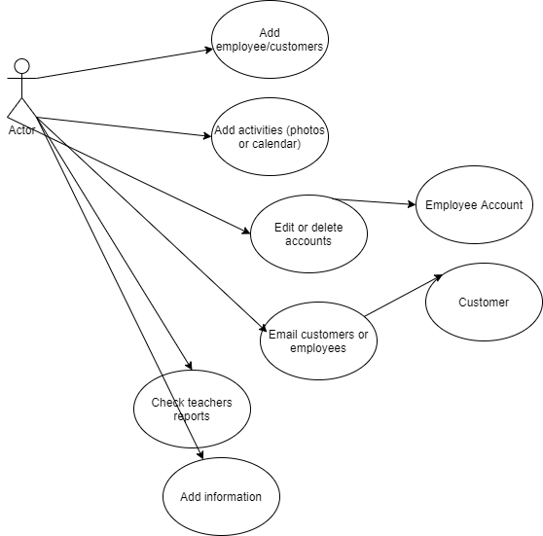























Use Case 2: Employee (Teachers)

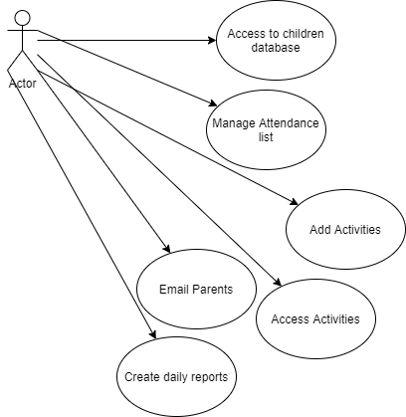











Use Case 3: Customer (Parent)







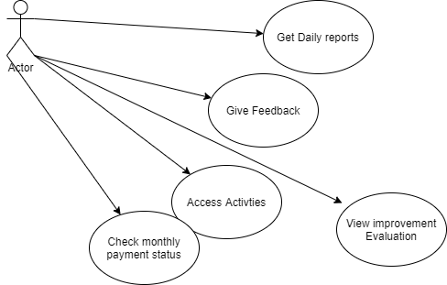



Use Case 4: Employee (Psychologist)  








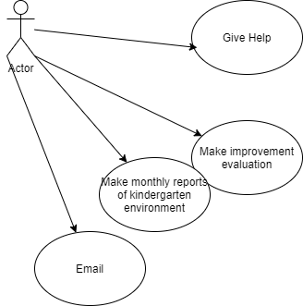





Use Case 5: Employee (Economist)







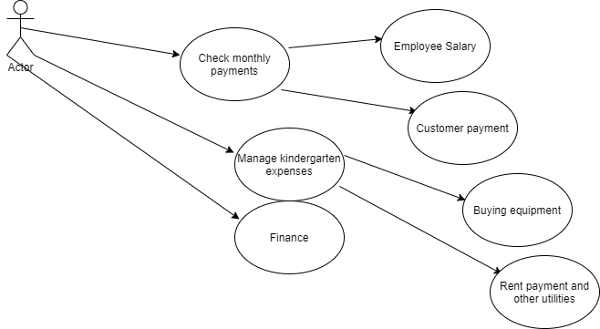



Use Case 6: General

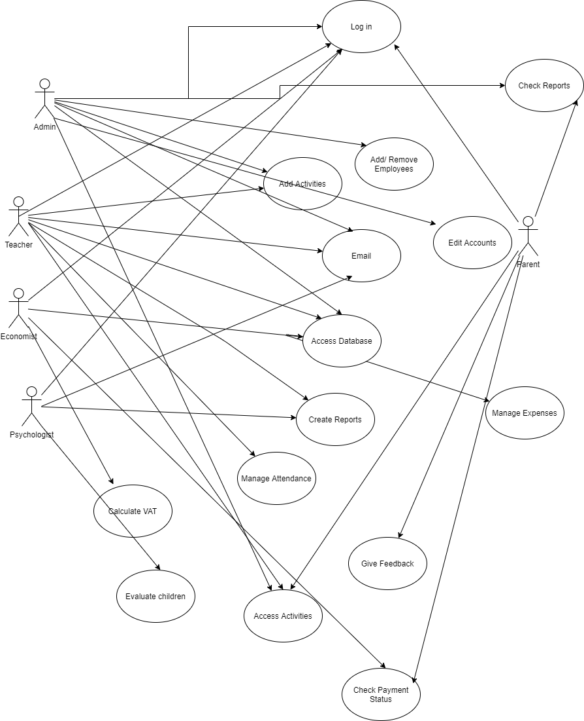

















 



**4.3 Use Cases Extended**

|  |  |
| --- | --- |
| Use Case (UC_1.1) | Add/Delete/Update new customer |
|  |  |
| Scope: | ABC Education (Kindergarten Management) |
|  |  |
| Level: | User Level |
|  |  |
| Intention Content: | To register/delete new children in the system and update the |
|  | others. |
|  |  |
| Minimum Guarantees: | The information is registered on the database. |
|  |  |
| Success Guarantees: | The information is shown in the app. |
|  |  |
| Primary Actor: | Administrator |
|  |  |
| Stakeholder’s Interest: | To have registered every child with their proper details. |
|  |  |
| Pre-condition: | Admin is logged in the system. |
|  |  |
|  |  |
| Use Case (UC_1.2) | Add/Delete/Update Information |
|  |  |
| Scope: | ABC Education (Kindergarten Management) |
|  |  |
| Level: | User Level |
|  |  |
| Intention Content: | To add and delete information about the kindergarten according |
|  | to the situation. |
|  |  |
| Minimum Guarantees: | The information is written properly on the page. |
|  |  |
| Success Guarantees: | The new/ deleted (updated) information is saved on the page. |
|  |  |
| Primary Actor: | Admin |
|  |  |
| Stakeholder’s Interest: | To keep all the parties informed. |
|  |  |
| Pre-condition: | Admin is logged in the system. |
|  |  |
|  |  |
| Use Case (UC_1.3) | Add/Delete/Update Activities |
|  |  |
| Scope: | ABC Education (Kindergarten Management) |
|  |  |
| Level: | User Level |
|  |  |

|  |  |
| --- | --- |
| Intention Content: | To add /delete activities about the kindergarten according to the |
|  | activities timetable. |
|  |  |
| Minimum Guarantees: | The activities are updated. |
|  |  |
| Success Guarantees: | Activities are shown and the parents and all interested parties |
|  | get informed about them. |
|  |  |
| Primary Actor: | Admin |
|  |  |
| Stakeholder’s Interest: | Parents/teachers etc are clear about the activites. |
|  |  |
| Pre-condition: | Admin is logged in the system and other parties are logged in in |
|  | order to access the information. |
|  |  |
|  |  |
| Use Case (UC_1.4) | Add/Delete/Update Employees |
|  |  |
| Scope: | ABC Education (Kindergarten Management) |
|  |  |
| Level: | User Level |
|  |  |
| Intention Content: | To have all the needed information about the teachers that are |
|  | currently working in the kindergarten. |
|  |  |
| Minimum Guarantees: | The employees are all registered. |
|  |  |
| Success Guarantees: | The information is accessible from the proper parties that might |
|  | need it. (economist, parent, psychologist etc) |
|  |  |
| Primary Actor: | Admin |
|  |  |
| Stakeholder’s Interest: | To have all the detailed information about the teachers since |
|  | they are the only ones who have direct contact with parents and |
|  | also children. |
|  |  |
| Pre-condition: | Admin is logged in the system and other parties are logged in in |
|  | order to access the information. |
|  |  |

|  |  |
| --- | --- |
| Use case 1.5 | create quick note for every employee |
| Scope | ABC Education (Kindergarten Management) |
| Level | User level |
| Intention context | to courage and motivate the employees |
| Minimum guarantees | Notes are post but not shown in the employees page |
| Success guarantees | Notes are shown in the employee page |
| Primary actor | Administrator |
| Stakeholder’s interest | To be updated and improve their work |
| Precondition | Admin should be logged in and there should be at least one employee. |

|  |  |
| --- | --- |
| Use 1.6 | Phone number connected with WhatsApp |
| Scope | ABC Education (Kindergarten Management) |
| Level | User level |
| Intention context | To easily communicate with parents |
| Minimum guarantees | Number is shown only for call |
| Success guarantees | Phone number when clicked links directly to WhatsApp and the message is sent. |
| Primary actor | Administrator |
| Stakeholder’s interes | To be updated with the condition of their children |
| Precondition | Admin should be logged in and numbers should be shown in database |

|  |  |
| --- | --- |
| Use 1.7 | Email of the kindergarten linked with the gmail. |
| Scope | ABC Education (Kindergarten Management) |
| Level | User level |
| Intention context | To communicate with parents for official events |
| Minimum guarantees | Email is shown but not connected with gmail directly. |
| Success guarantees | Email of the kindergarten linked directly with gmail and message sent to the specific parents. |
| Primary actor | Administrator |
| Stakeholder’s interest | To be updated and to follow the events of the kindergarten |
| Precondition | Admin should be logged in and emails should be shown in database |

|  |  |
| --- | --- |
| Use 1.8 | Printing information |
| Scope | ABC Education (Kindergarten Management) |
| Level | User level |
| Intention context | To have a document with all the information needed for all the children |
| Minimum guarantees | Print button is shown but does not take all the information |
| Success guarantees | Every information is shown in the print document |
| Primary actor | Administrator |
| Stakeholder’s interest | To have documents of all the information of their children |
| Precondition | Admin should be logged in and view the database |

|  |  |
| --- | --- |
| Use 1.9 | write feedback for teachers reports |
| Scope | ABC Education (Kindergarten Management) |
| Level | User level |
| Intention context | To control the work of the teachers |
| Minimum guarantees | To view and access the reports |
| Success guarantees | To give feedbacks for every report |
| Primary actor | Administrator |
| Stakeholder’s interest | To improve the work and to stay updated |
| Precondition | Admin should be logged in and have access in reports |

|  |  |
| --- | --- |
| Use case 1.10 | Changing the password and the username |
| Scope | ABC Education (Kindergarten Management) |
| Level | User level |
| Intention context | Have a secure, unique and private log in |
| Minimum guarantees | Setting section is shown to change username and password is shown |
| Success guarantees | All the changings are saved |
| Primary actor | Administrator |
| Stakeholder’s interest | Be secure that username and password is unique |
| Precondition | Admin should be logged in first |

|  |  |
| --- | --- |
| Use case 1.11 | Phone number connected with WhatsApp |
| Scope | ABC Education (Kindergarten Management) |
| Level | User level |
| Intention context | To easily communicate with employees |
| Minimum guarantees | Number is shown only for call |
| Success guarantees | Phone number when clicked links directly to WhatsApp and the message is sent. |
| Primary actor | Administrator |
| Stakeholder’s interest | To be updated with the latest emergencies |
| Precondition | Admin should be logged in and numbers should be shown in the database of the employees. |

|  |  |
| --- | --- |
| Use case 1.12 | Email of the kindergarten linked with gmail. |
| Scope | ABC Education (Kindergarten Management) |
| Level | User level |
| Intention context | To communicate with employees for official events |
| Minimum guarantees | Email is shown but not connected with gmail directly. |
| Success guarantees | Email of the kindergarten linked directly with gmail and message sent to the specific employee. |
| Primary actor | Administrator |
| Stakeholder’s interest | Staying updated with the last events in the kindergarten |
| Precondition | Admin should be logged in and emails should be shown in the database of the employees. |

|  |  |
| --- | --- |
| Use Case 2.1 | Writing notes for the teacher |
| Scope | ABC Education (Kindergarten Management) |
| Level | User level |
| Intention context | To ask special request to teachers |
| Minimum guarantees | Notes are written but not shown in teacher’s page |
| Success guarantees | Teacher receives the notes |
| Primary actor | Parent |
| Stakeholder’s interest | To be updated with the condition and special requests for each child |
| Precondition | Parent should be logged in |

|  |  |
| --- | --- |
| Use Case 2.2 | Changing the password |
| Scope | ABC Education (Kindergarten Management) |
| Level | User level |
| Intention context | Have a secure, unique and private log in |
| Minimum guarantees | Setting section is shown to change username and password is shown |
| Success guarantees | All the changings are saved |
| Primary actor | Parent |
| Stakeholder’s interest | Be secure that username and password is unique |
| Precondition | Parent should be logged in first |

|  |  |
| --- | --- |
| Use Case 2.3 | Edit/Delete the data |
| Scope | ABC Education (Kindergarten Management) |
| Level | User level |
| Intention context | To edit and delete specific information about their child |
| Minimum guarantees | The information is registered on the database. |
| Success guarantees | The information is shown in the app |
| Primary actor | Parent |
| Stakeholder’s interest | To update the information in order to create a better interaction |
| Precondition | Should be logged in |

|  |  |
| --- | --- |
| Use Case 2.4 | Upload the mandate |
| Scope | ABC Education (Kindergarten Management) |
| Level | User level |
| Intention context | To show to admin that the monthly payment is done |
| Minimum guarantees | Mandate submitted |
| Success guarantees | Changes saved and reflected to admin |
| Primary actor | Parent |
| Stakeholder’s interest | To check if all payments are done |
| Precondition | Parent should be logged in and have picture of the tac coupon |

|  |  |
| --- | --- |
| Use Case 2.5 | Printing information |
| Scope | ABC Education (Kindergarten Management) |
| Level | User level |
| Intention context | To have a document with all the information needed for their children registered in the kindergarten |
| Minimum guarantees | Print button is shown but does not take all the information |
| Success guarantees | Every information is shown in the print document |
| Primary actor | Parent |
| Stakeholder’s interest | To have documentation with the information needed |
| Precondition | Parent should be logged in |

|  |  |
| --- | --- |
| Use Case 3.1 | Upload the tax Coupon of the salary |
| Scope | ABC Education (Kindergarten Management) |
| Level | User level |
| Intention context | To show to admin that the salary is taken |
| Minimum guarantees | Tax coupon of salary is submitted |
| Success guarantees | Changes saved and reflected to admin |
| Primary actor | Teacher |
| Stakeholder’s interest | To check if all employees took the salary |
| Precondition | Teacher should be logged in |

|  |  |
| --- | --- |
| Use case 3.2 | Changing the password |
| Scope | ABC Education (Kindergarten Management) |
| Level | User level |
| Intention context | Have a secure, unique and private log in |
| Minimum guarantees | Setting section is shown to change username and password is shown |
| Success guarantees | All the changings are saved |
| Primary actor | Teacher |
| Stakeholder’s interest | Be secure that username and password is unique |
| Precondition | Teacher should be logged in |

|  |  |
| --- | --- |
| Use case 3.2 | Filling the attendendance. |
| Scope | ABC Education (Kindergarten Management) |
| Level | User level |
| Intention context | To update parents if the child has been present or absent |
| Minimum guarantees | The table of all the children names shown |
| Success guarantees | Filling the attendance sheet daily and saving changes |
| Primary actor | Teacher |
| Stakeholder’s interest | Informing parents about the attendance of their child |
| Precondition | Teacher should be logged in and have access to the database shown |

|  |  |
| --- | --- |
| Use 3.3 | Phone number connected with WhatsApp |
| scope | ABC Education (Kindergarten Management) |
| level | User level |
| Intention context | To easily communicate with parents |
| Minimum guarantees | Number is shown only for call |
| Success guarantees | Phone number when clicked links directly to WhatsApp and the message is sent. |
| Primary actor | Teacher |
| Stakeholder’s interes | To be updated with the condition of their children |
| Precondition | Teacher should be logged in and numbers should be shown in database |

|  |  |
| --- | --- |
| Use case 3.4 | Email of the kindergarten linked with gmail. |
| Scope | ABC Education (Kindergarten Management) |
| Level | User level |
| Intention context | To communicate with parents for official events |
| Minimum guarantees | Email is shown but not connected with gmail directly. |
| Success guarantees | Email of the kindergarten linked directly with gmail and message sent to the specific parents . |
| Primary actor | Teacher |
| Stakeholder’s interest | Staying updated with the last events in the kindergarten |
| Precondition | Teachers should be logged in and emails should be shown in the database. |

|  |  |
| --- | --- |
| Use Case 3.5 | Writing notes for the parent |
| Scope | ABC Education (Kindergarten Management) |
| Level | User level |
| Intention context | To respond to special request from parents |
| Minimum guarantees | Notes are written but not shown in parent’s page |
| Success guarantees | Parent receives the notes |
| Primary actor | Teacher |
| Stakeholder’s interest | To be updated with the condition and special requests for each child |
| Precondition | Teachers should be logged in |

|  |  |
| --- | --- |
| Use 3.6 | Writing reports |
| Scope | ABC Education (Kindergarten Management) |
| Level | User level |
| Intention context | Reporting to admin every week about the overall situation in the kindergarten |
| Minimum guarantees | Reports written weekly |
| Success guarantees | Uploading reports |
| Primary actor | Teacher |
| Stakeholder’s interest | Being updated with the interaction between teachers and children |
| Precondition | Teachers should be logged in |

|  |  |
| --- | --- |
| Use Case 4.1 | Reporting the exact date of monthly payment |
| Scope | ABC Education (Kindergarten Management) |
| Level | User level |
| Intention context | To make sure that everything is being reported on time |
| Minimum guarantees | Having access to the calendar |
| Success guarantees | Submitting and saving the changes |
| Primary actor | Economist |
| Stakeholder’s interest | Check if the parents have done the monthly payment of the kindergarten |
| Precondition | Economist should be logged in |

|  |  |
| --- | --- |
| Use Case 4.2 | upload the mandate of the monthly payment of the kindergarten |
| Scope | ABC Education (Kindergarten Management) |
| Level | User level |
| Intention context | To make sure that everything is transparent between admin and parent |
| Minimum guarantees | Mandate submitted |
| Success guarantees | All changes saved |
| Primary actor | Economist |
| Stakeholder’s interest | Check if the parents have done the monthly payment of the kindergarten |
| Precondition | Economist should be logged in |

|  |  |
| --- | --- |
| Use Case 4.3 | Reporting the deadline date of next monthly payment |
| Scope | ABC Education (Kindergarten Management) |
| Level | User level |
| Intention context | To make sure that admin is aware of the date of the next payment |
| Minimum guarantees | Having access to the calendar |
| Success guarantees | Submitting and saving the changes |
| Primary actor | Economist |
| Stakeholder’s interest | Being updated and prepared for the next payment |
| Precondition | Economist should be logged in |

|  |  |
| --- | --- |
| Use Case 4.4 | upload the tax coupon payment of the kindergarten |
| Scope | ABC Education (Kindergarten Management) |
| Level | User level |
| Intention context | To make sure that everything is transparent and to inform the admin of all the expenses and costs |
| Minimum guarantees | Tax of Coupon submitted |
| Success guarantees | All changes saved |
| Primary actor | Economist |
| Stakeholder’s interest | Being aware of the expenses of the kindergarten |
| Precondition | Economist should be logged in |

|  |  |
| --- | --- |
| Use Case 4.5 | upload the excel sheet with the calculation of the VAT |
| Scope | ABC Education (Kindergarten Management) |
| Level | User level |
| Intention context | Making calculations about the monthly incomes and costs and then calculating if VAT should be paid that month or not |
| Minimum guarantees | Filling excel sheet |
| Success guarantees | All changes saved and excel sheet uploaded |
| Primary actor | Economist |
| Stakeholder’s interest | Being aware of the monthly expenses, incomes of the kindergarten and being aware of the value of VAT |
| Precondition | Economist should be logged in and have installed Excel |

|  |  |
| --- | --- |
| Use Case 4.6 | Printing information |
| Scope | ABC Education (Kindergarten Management) |
| Level | User level |
| Intention context | To have a document with all the information needed for taxes, incomes and costs |
| Minimum guarantees | Print button is shown but does not take all the information |
| Success guarantees | Every information is shown in the print document |
| Primary actor | Parent |
| Stakeholder’s interest | To have documentation with the information needed |
| Precondition | Parent should be logged in |

|  |  |
| --- | --- |
| Use Case 5.1 | Writing notes for the parent |
| Scope | ABC Education (Kindergarten Management) |
| Level | User level |
| Intention context | To report about the mental health of each child |
| Minimum guarantees | Notes are written but not shown in parent’s page |
| Success guarantees | Parent receives the notes |
| Primary actor | Psychologist |
| Stakeholder’s interest | To be updated with the condition of each child |
| Precondition | Psychologist should be logged in and have access to database |

|  |  |
| --- | --- |
| Use Case 5.2 | Printing information |
| Scope | ABC Education (Kindergarten Management) |
| Level | User level |
| Intention context | To have a document with all the information about the mental health of the children in order to measure the progress of each of them |
| Minimum guarantees | Print button is shown but does not take all the information |
| Success guarantees | Every information is shown in the print document |
| Primary actor | Psychologist |
| Stakeholder’s interest | To have documentation with the information needed |
| Precondition | Psychologist should be logged in |

**4.4. Data flow diagram**

**DFD Level 0**

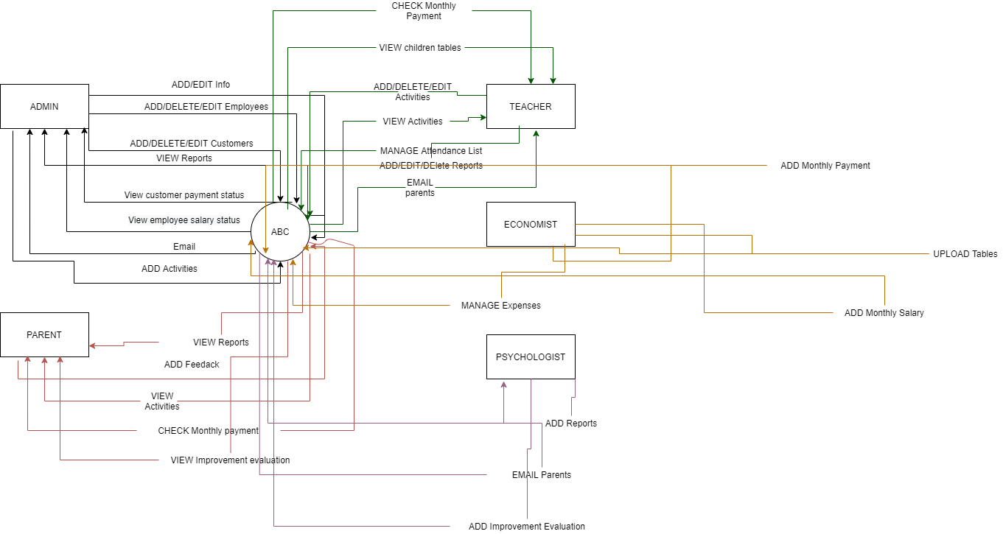**DFD Level 1**

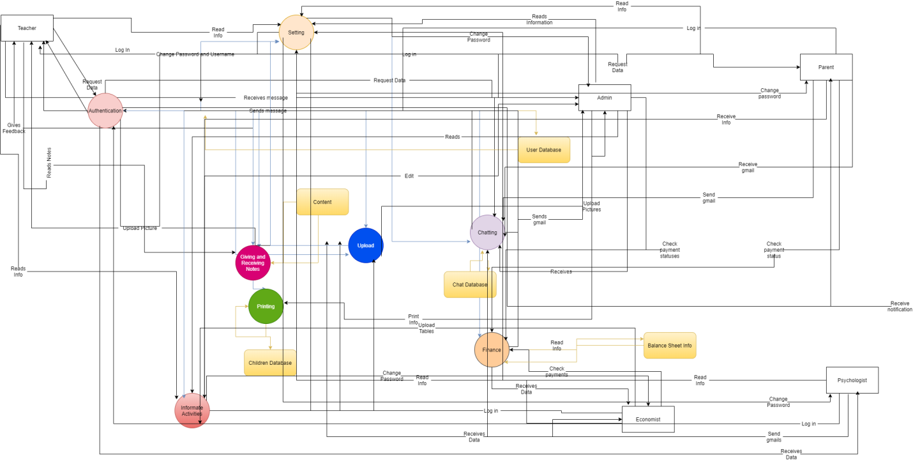

**DFD Level 3**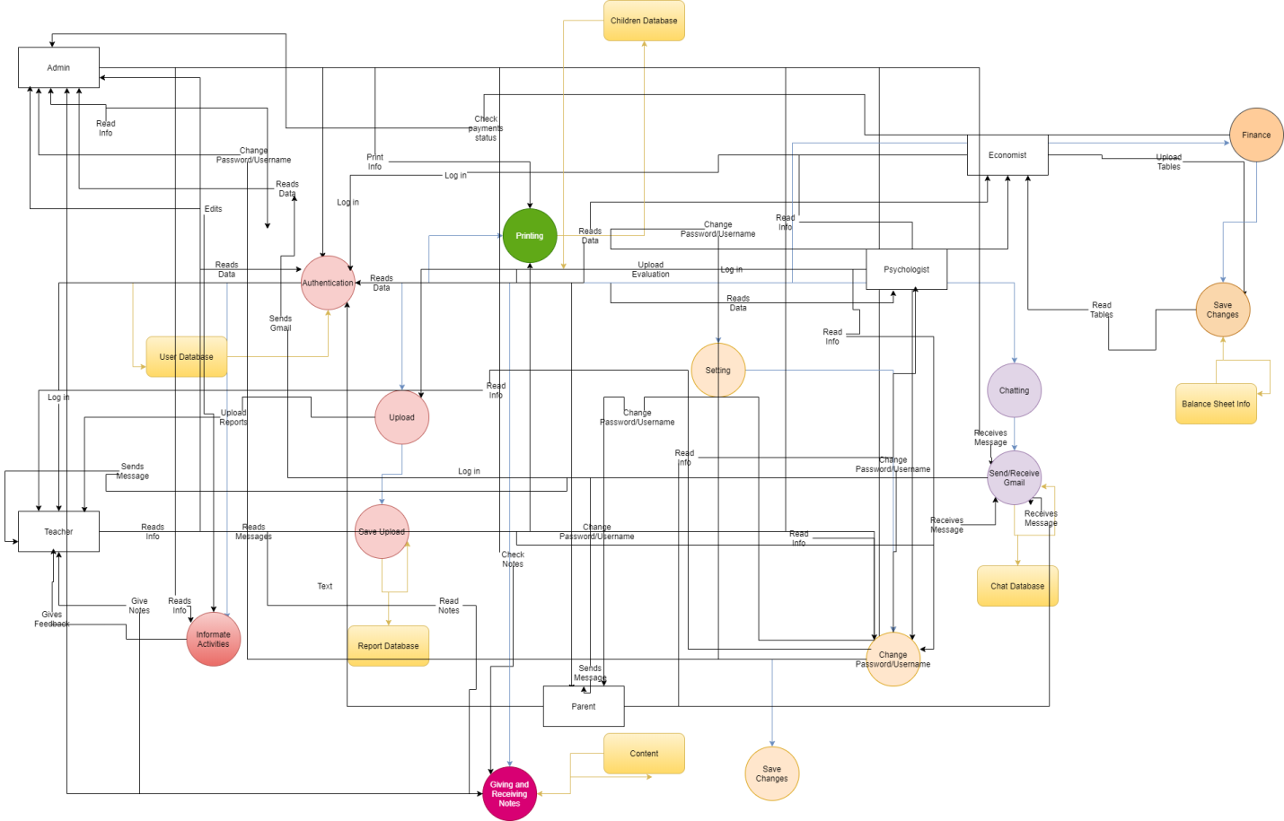

**4.5 Activity Diagrams**

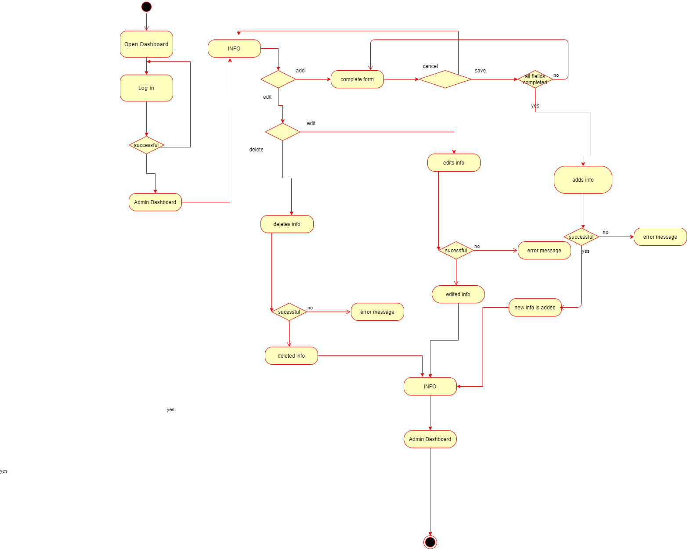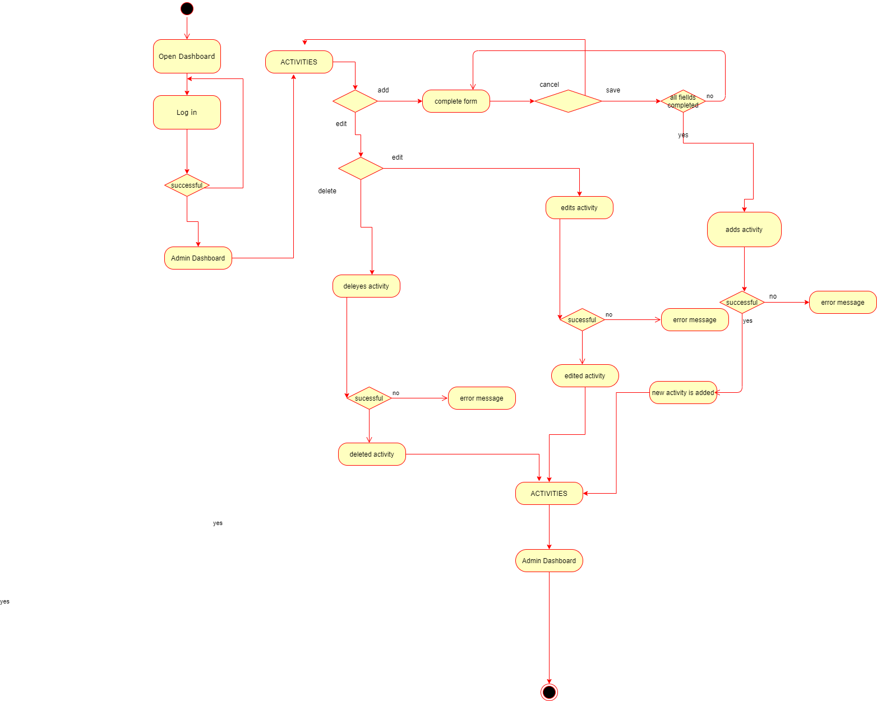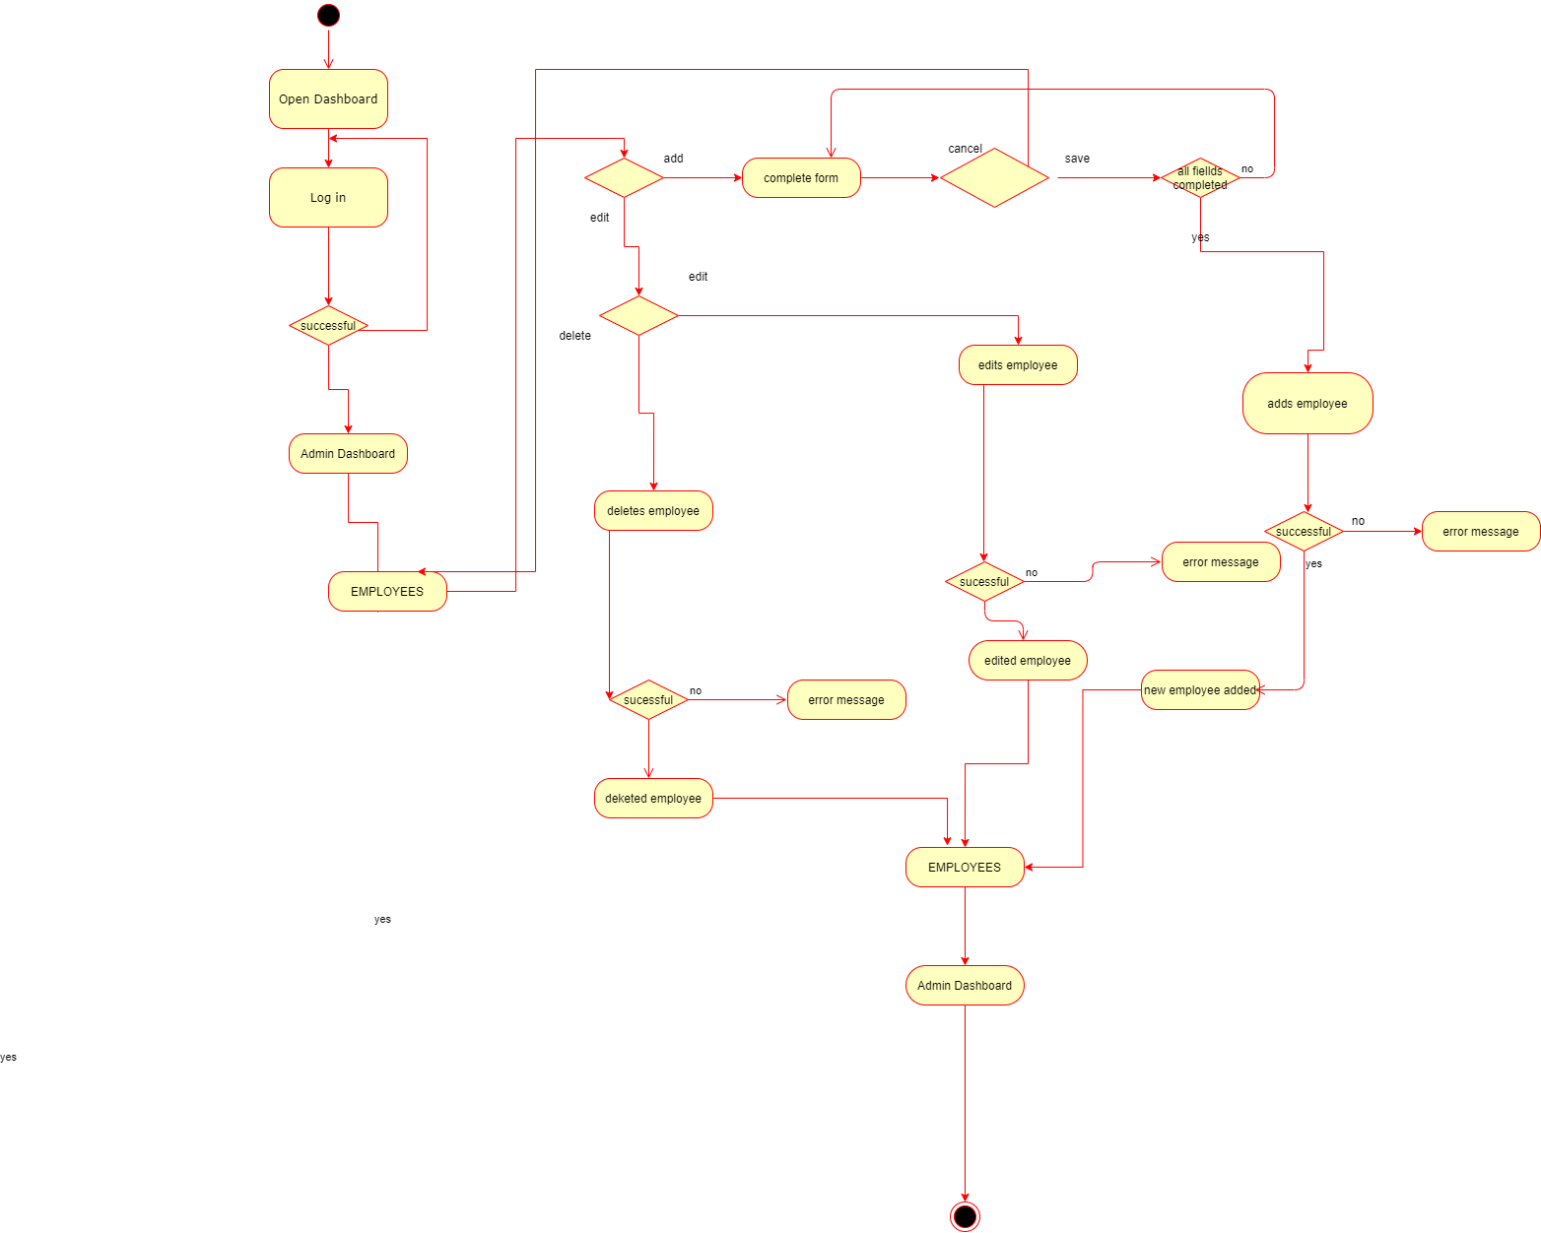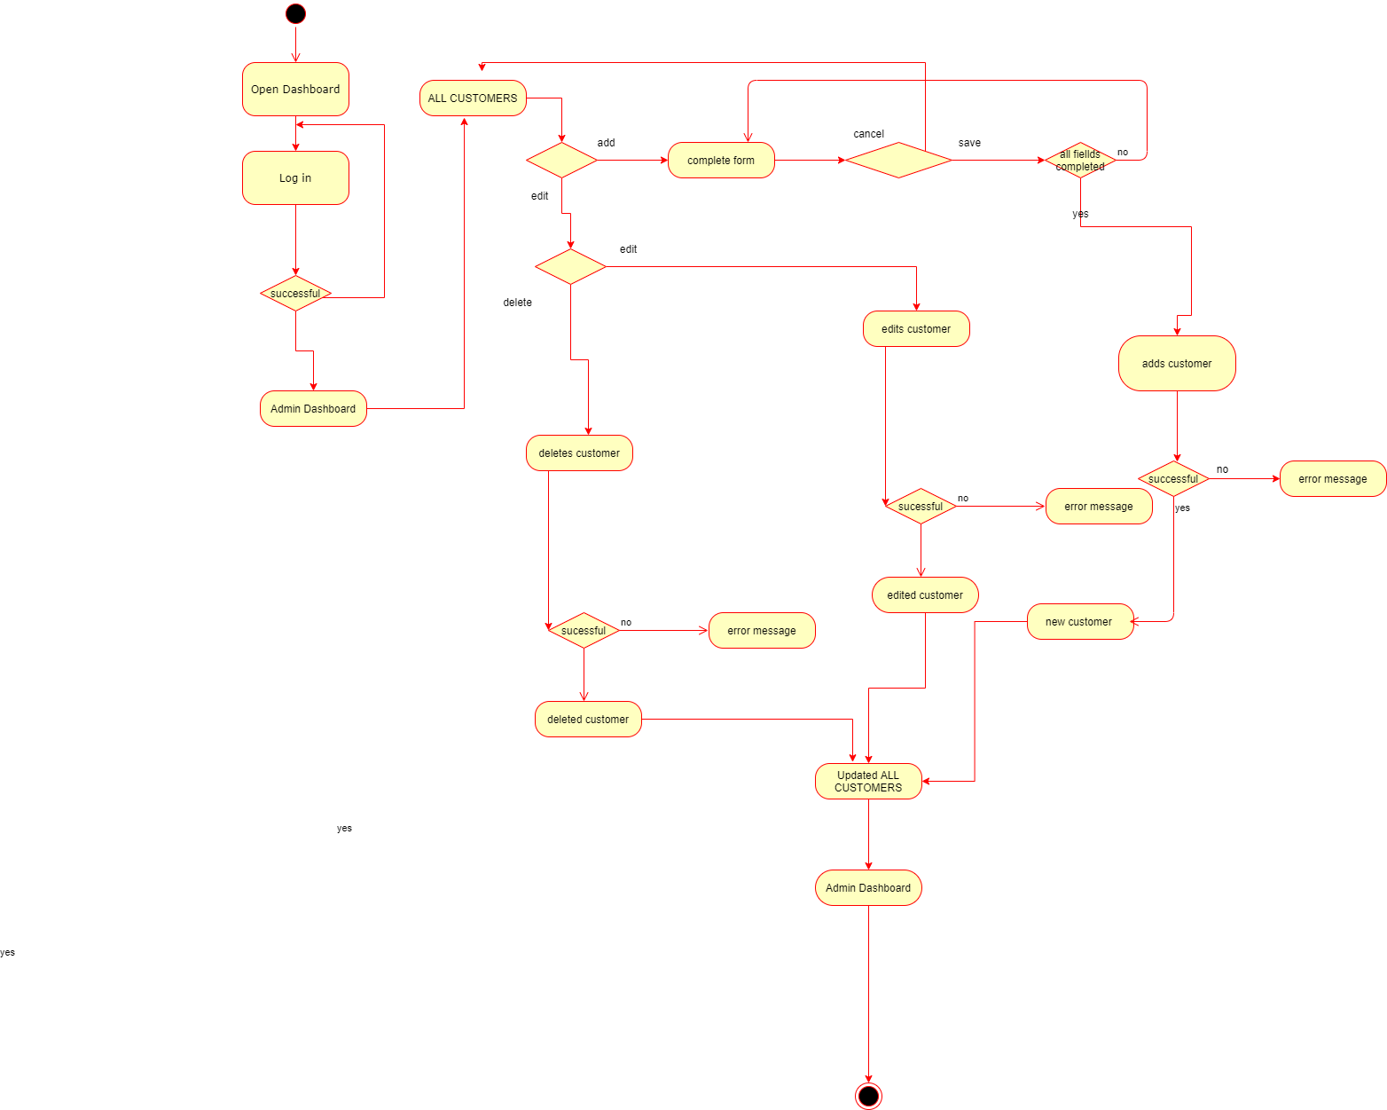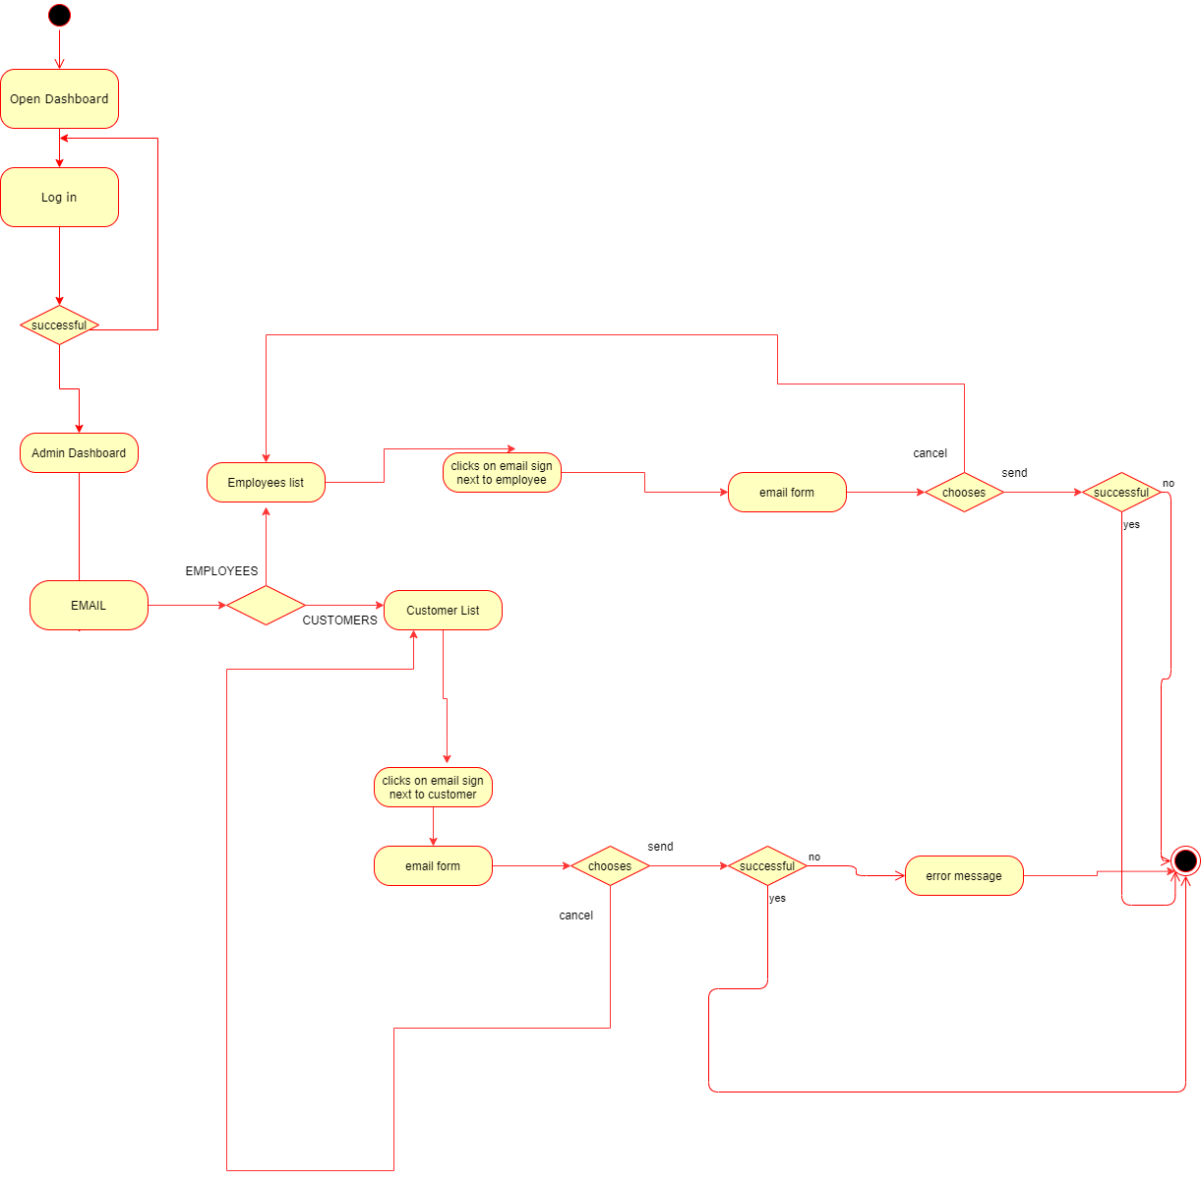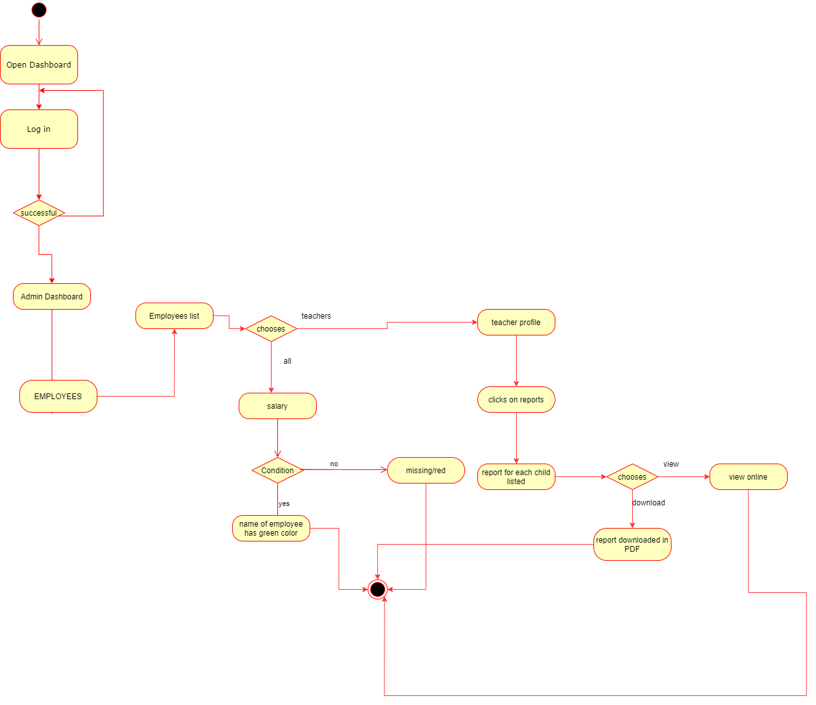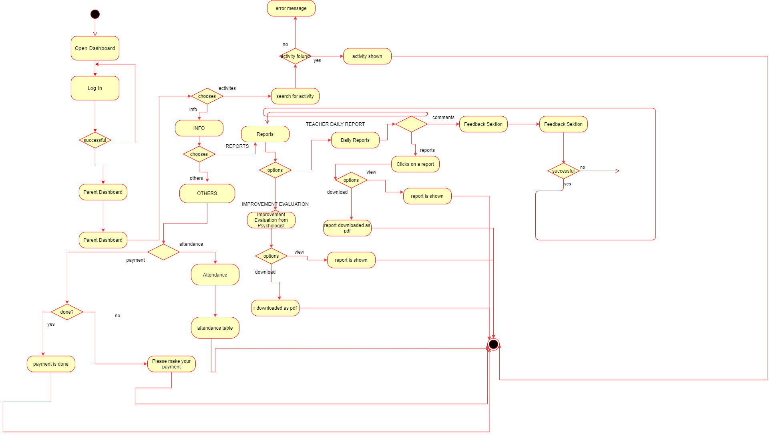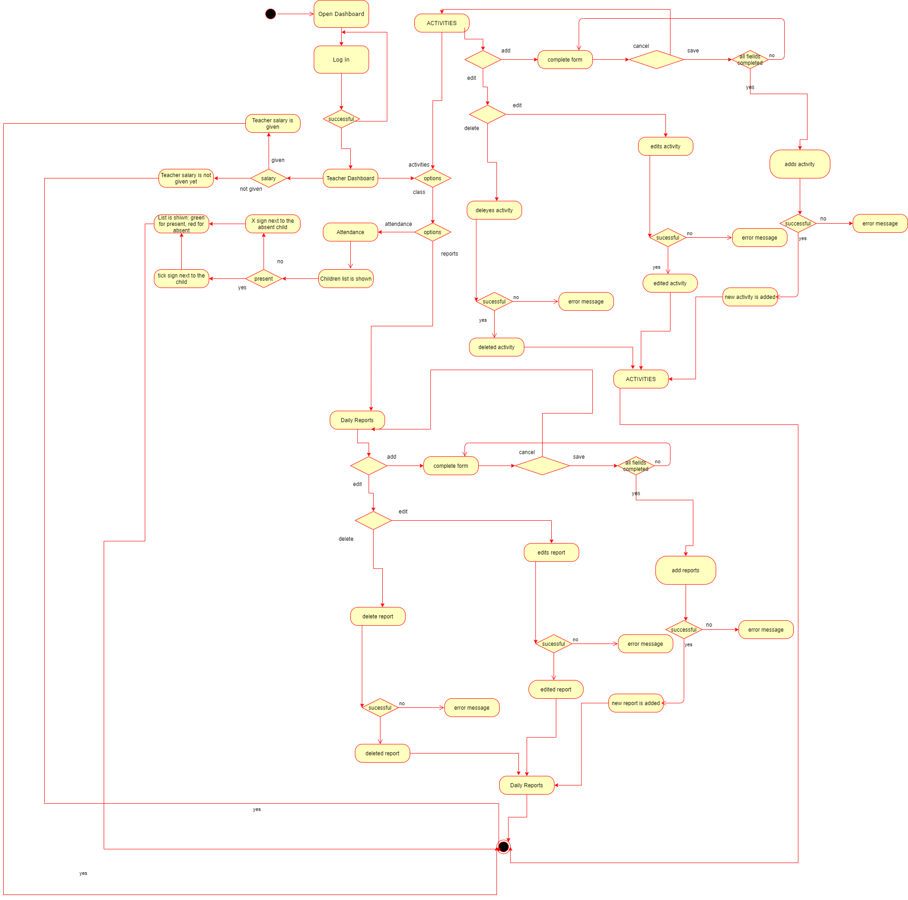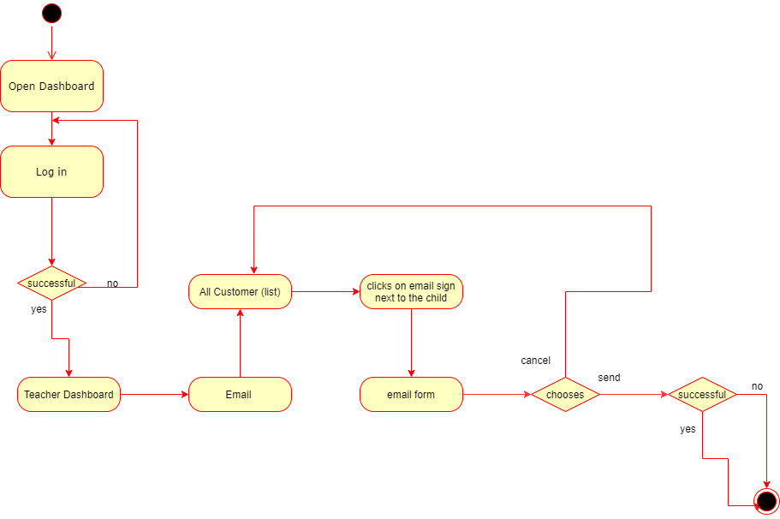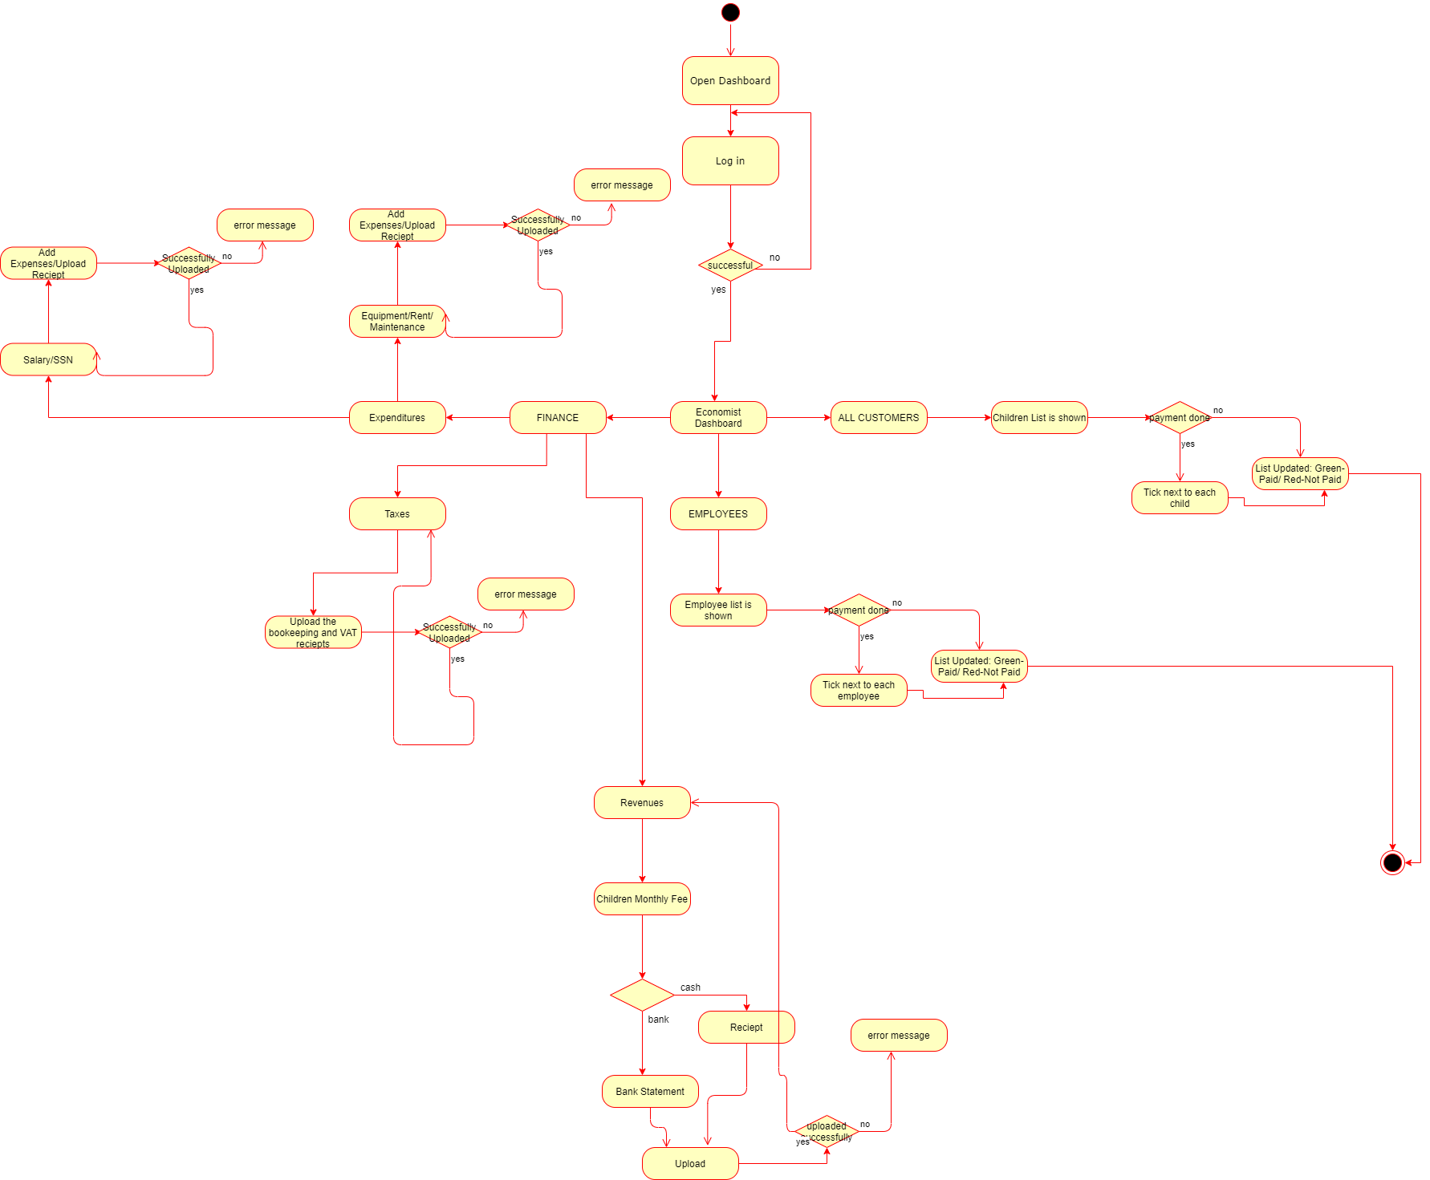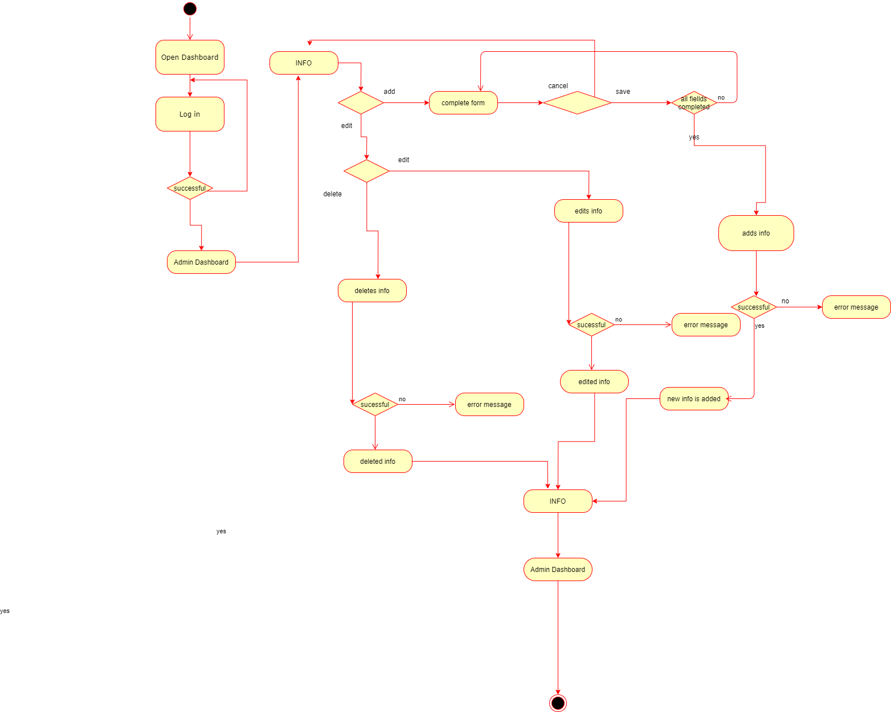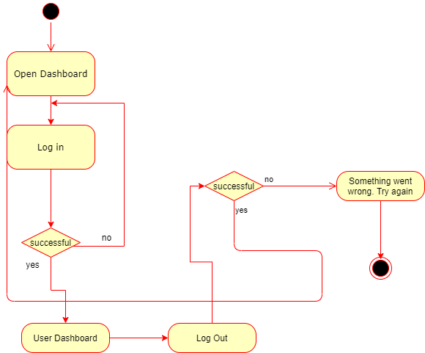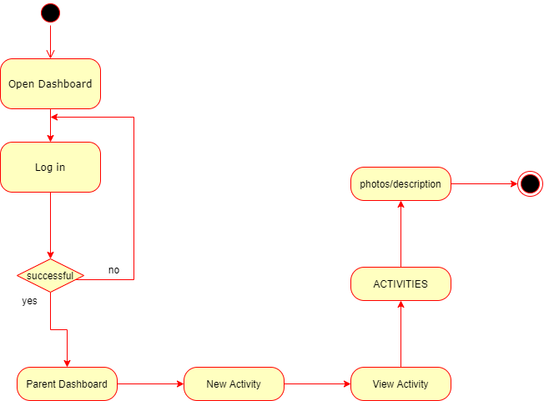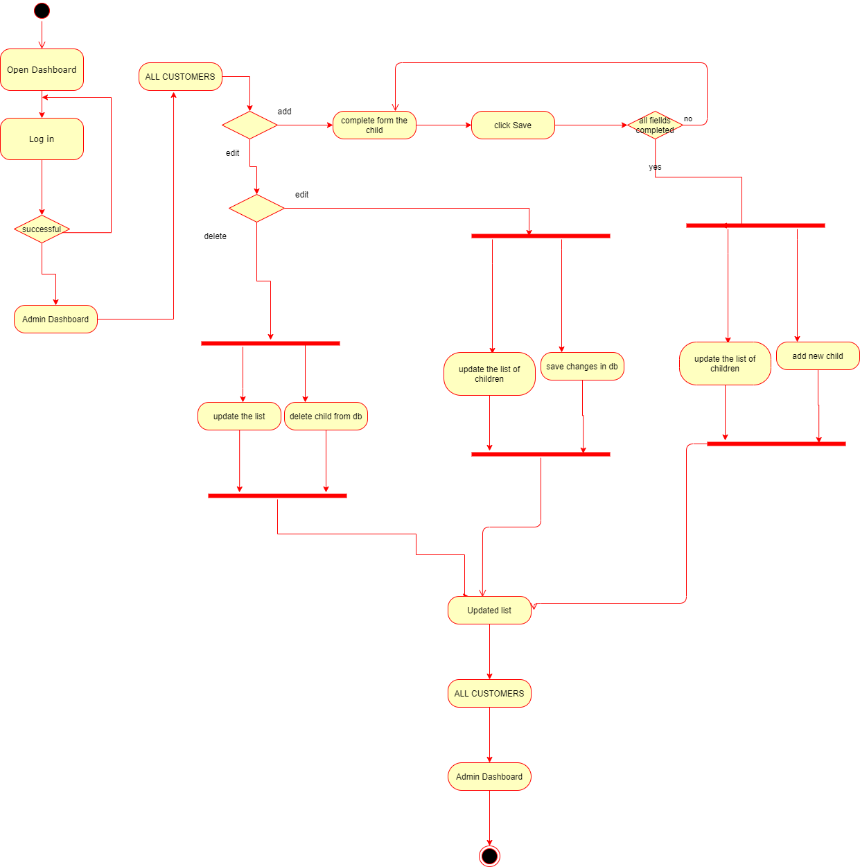

**4.6 Collaboration Diagram**

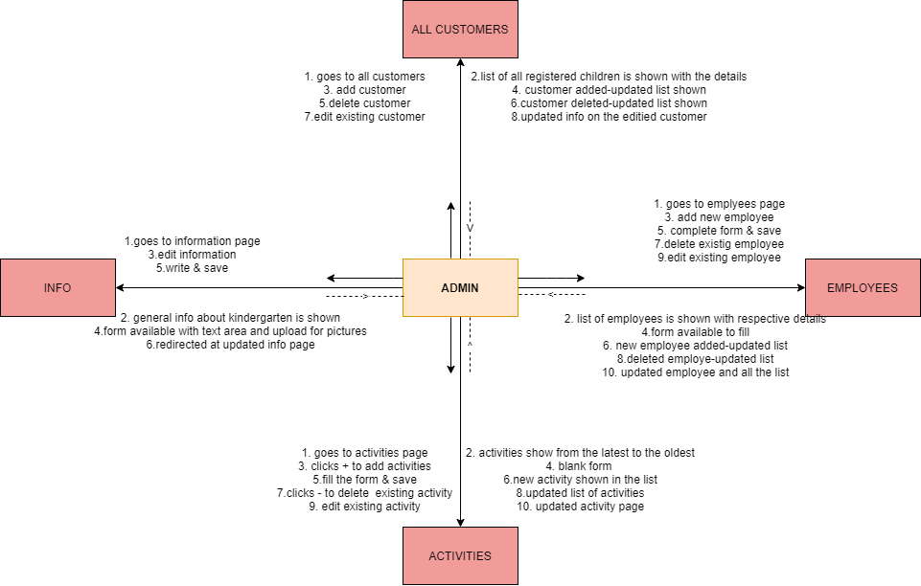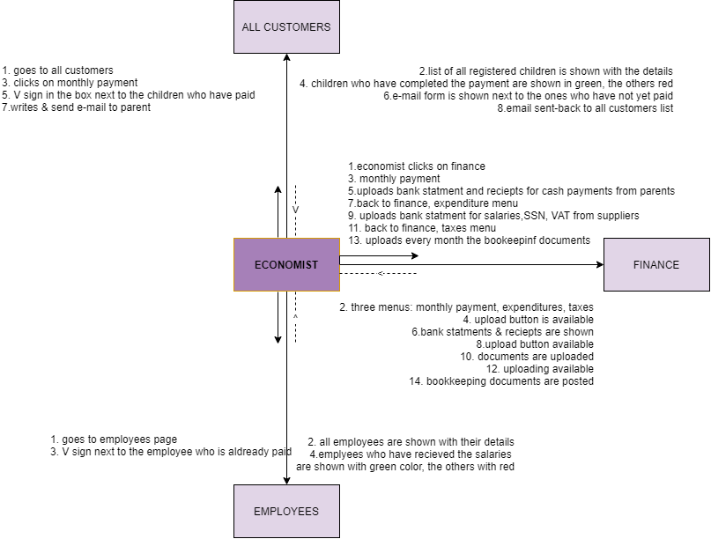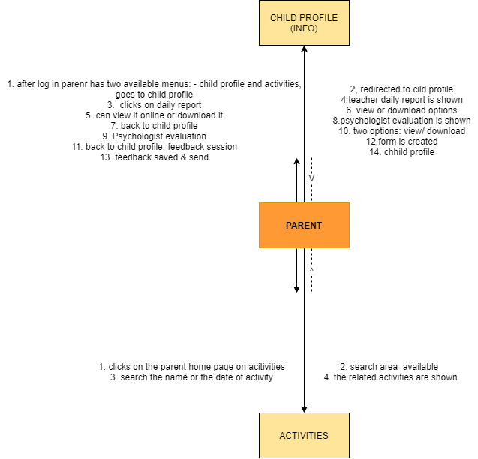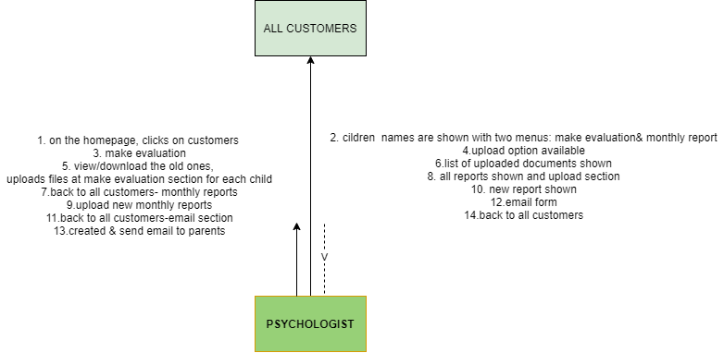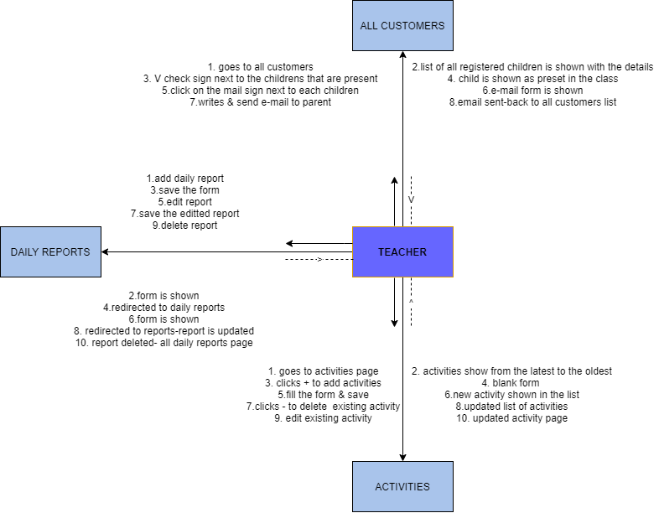

**4.7 Sequence Diagrams**

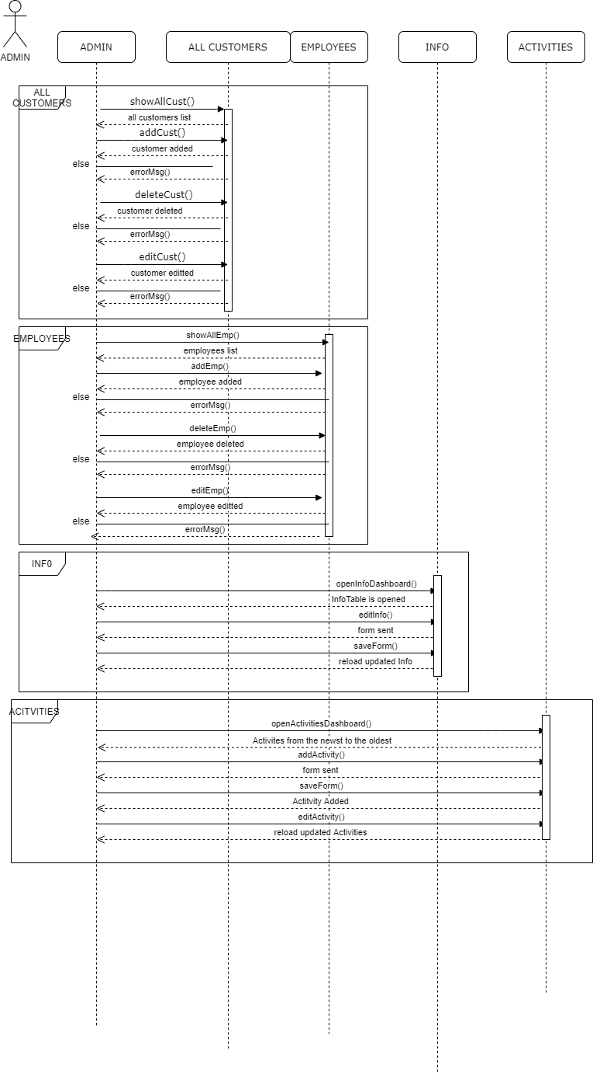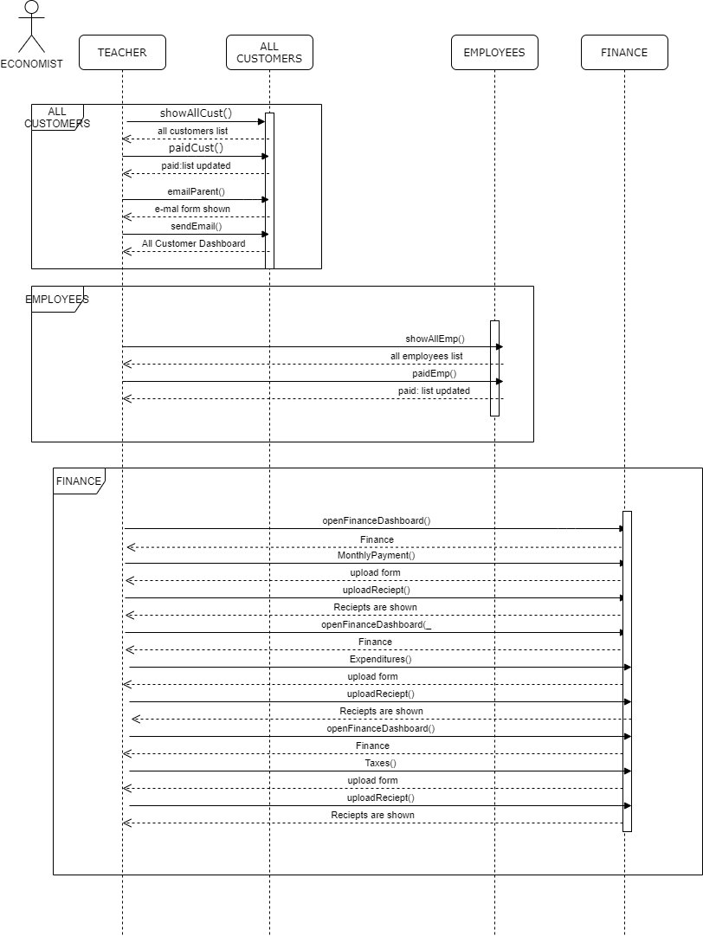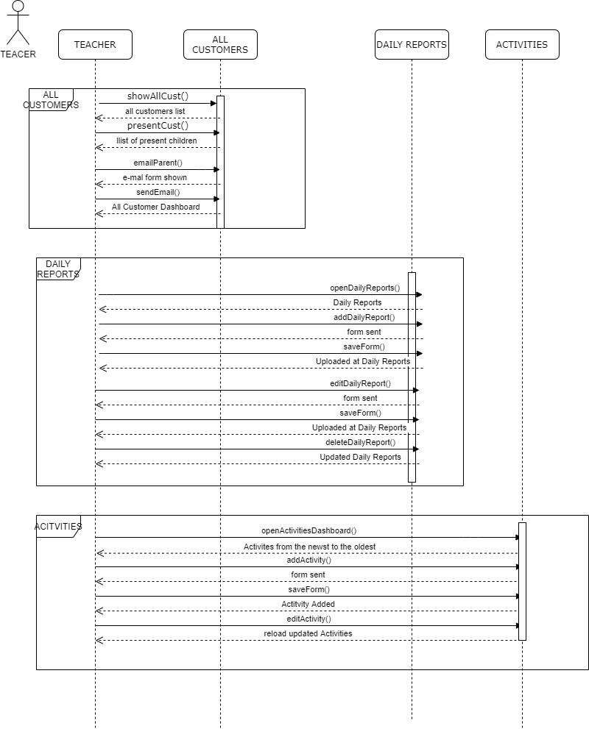

**4.8 Class Diagram**

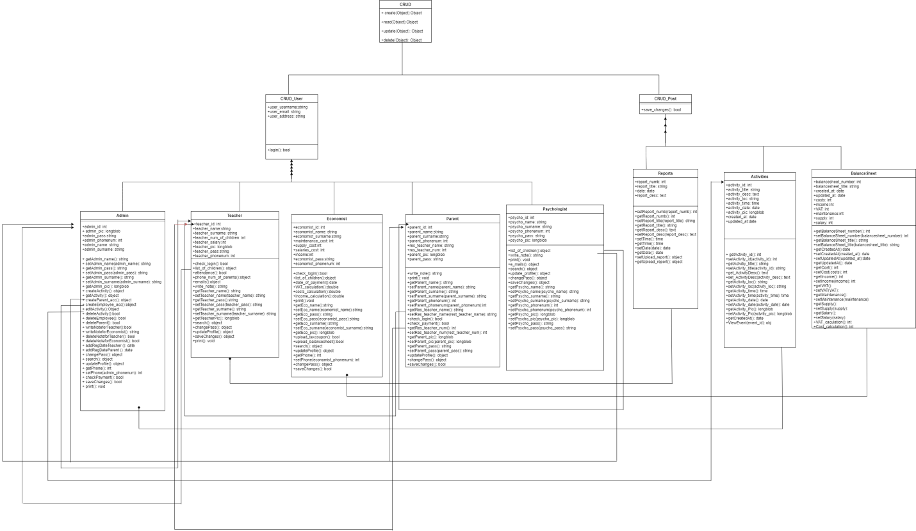

**4.9 ER diagram**

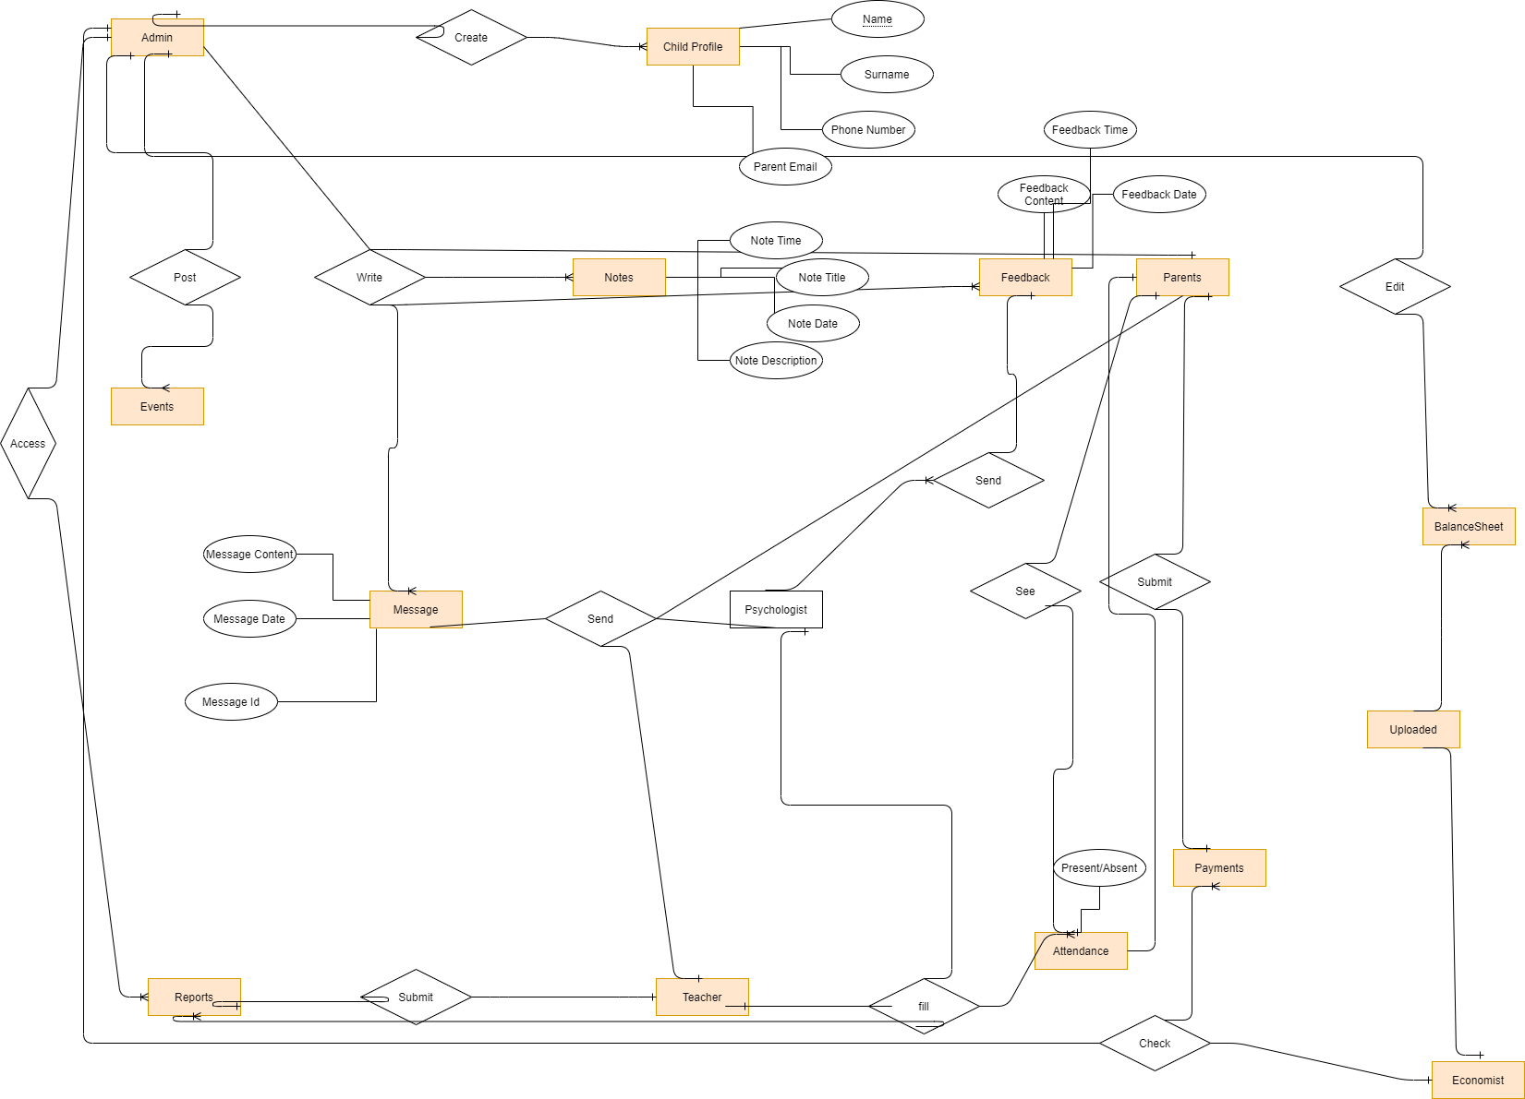

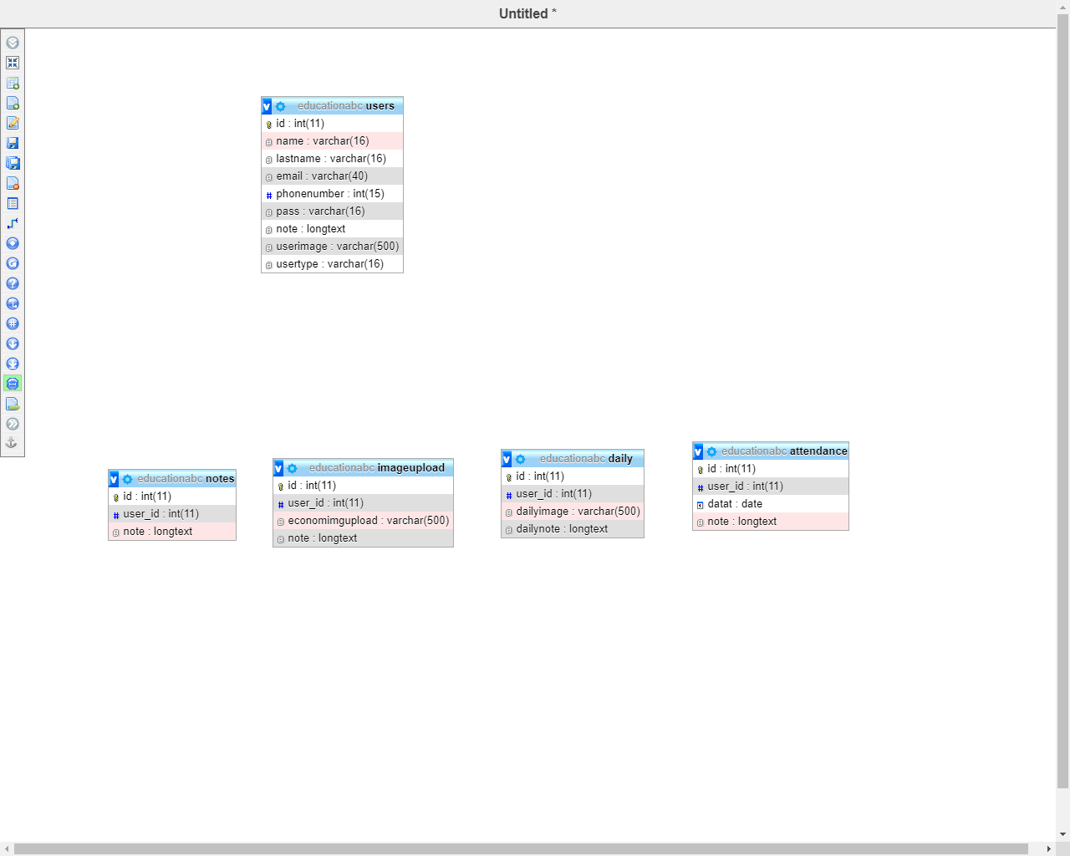

**4.10 Object Diagram**

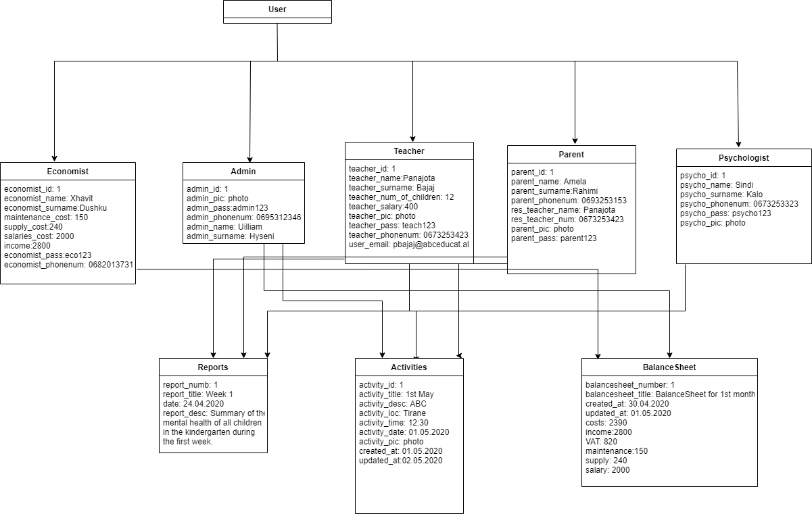

**4.11 Component Diagram**

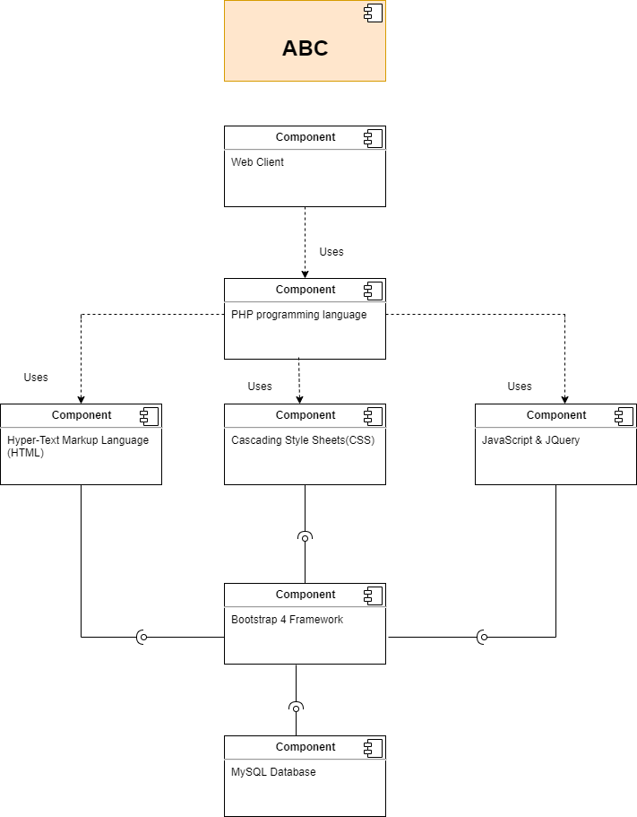

**4.12 Deployment Diagram**

